Rebets Splendour

Short Description

Rebets Splendour Slots is a one of a kind online slot game with an incredibly rewarding Re-spin Feature. If you’re unfamiliar, that means that every time you spin but don’t get a winning line, you can re-spin specific reels, giving you extra chances to win! So, dress to impress and play today! There are yachts, diamond rings, delicious lobster and blocks of gold across the reels, in addition to the 2 main characters. Pour yourself a martini and get ready for the most lavish gaming experience online. Plus, you can play on your mobile anytime, anywhere, so you’ll never miss a win!

**Formats**

* Stand Alone
* Embedded
* Mobile

**Recommended categories**

* Action
* Huge Wins

Marketing Materials

The materials can be downloaded from [here](https://files.eyecon.com/index.php/s/KkpZncTwzbW01QA)

Screenshots

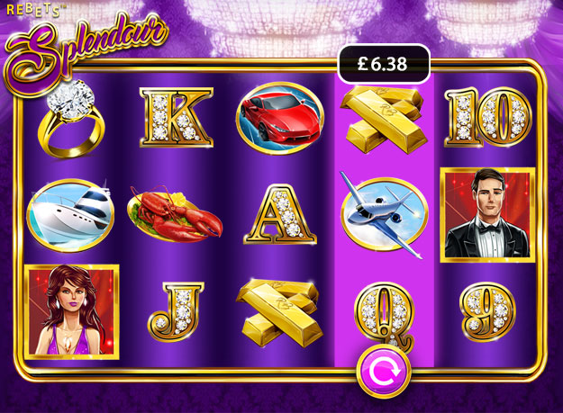

Game Properties & Features

|  |  |
| --- | --- |
| **Properties** | |
| **RTP (%)** | 97.073% |
| **Number of Reels** | 5 |
| **Number of Lines** | 25 |
| **Game Play** | Medium |
| **Volatility** | Medium |
| **Hit Rate playing 1 line** | 1 in 7.5 |
| **Combined Feature Hit Rate** | 1 in 113 |
| **Supports Free Spins** | Yes |
| **Features** | |
| Free Spins | Up to 25 |
| Substitute | Prizes are tripled |