Rich Pickins

Short Description

Harvest some major jackpots in our new game Rich Pickns! Land the apple in the basket and our bear would help you to win big. Land all the three fruits in the basket and your winning would become even bigger with our special mini games in which you can multiple your prize up to X200. So play Rich Pickins now and you’ll discover that money actually grows on trees!

Screenshots

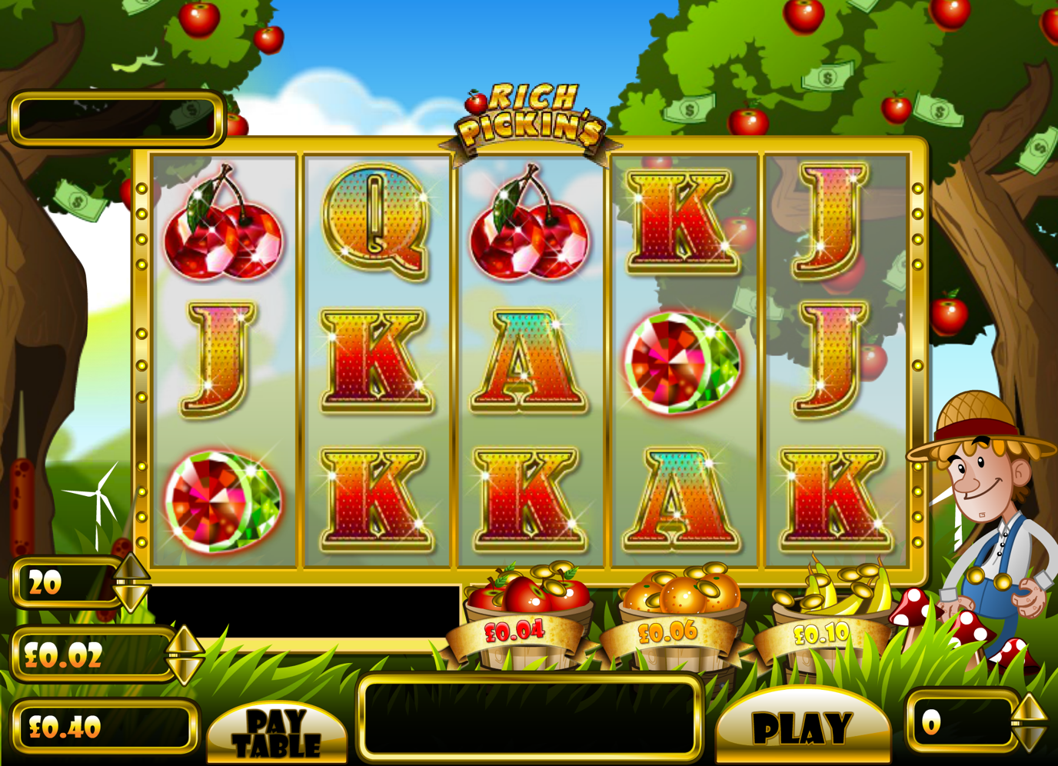

Game Properties & Features

|  |  |
| --- | --- |
| **Properties** | |
| Versions | SA |
| RTP (%) | 95.25% |
| Number of Reels | 5 |
| Number of Lines | 20 |
| Min. Bet | 0.01 |
| Max Bet | 40.00 |
| Game Play | Medium |
| Volatility | High |
| Hit Rate playing 1 line | 1:25 |
| (not Combined Feature Hit Rate | 1:251 |
| Default Bet | 0.02 |
| Supports Free Spins | No |
| Recommended Categories | * Farm/Market/Friut |
| **Features** | |
| Free Spins | No |
| Substitute | Yes |
| Prize Pick Feature | Yes |