RIDING HOOD RICHES

Short Description

Skip your way to Grandma’s house and pack your basket full of fortunes! Cook up a treat in Grandma’s kitchen as the Wolf serves some wild wins! Chase your fortunes in a massive 25 Free Games! My! What big wins you’ll have in this exciting 5 Reel, 25 Line slot game! Prizes are doubled during Free Games. Prize Pick triggered by 3 or more Wolf symbols and each pick can award a prize of up to 100x your total wager!

Marketing Materials

The materials can be downloaded from [here](https://files.eyecon.com/index.php/s/C9Shj3oA5eZp5IY)

Screenshots

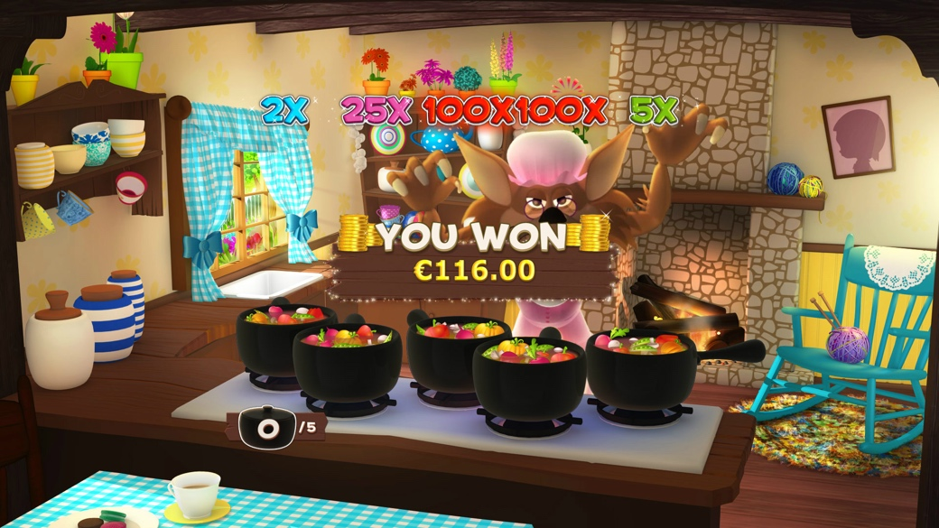



Game Properties & Features

|  |  |
| --- | --- |
| **Properties** | |
| Versions | Standalone |
| RTP (%) | 95 |
| Number of Reels | 5 |
| Number of Lines | 25 |
| Min. Bet | 1 credit |
| Max Bet | 50 credits |
| Game Play | Medium |
| Volatility | Low |
| Hit Rate playing 1 line | 1 in 17.1 |
| Combined Feature Hit Rate | 1 in 117.3 |
| Default Bet | 1 credit per line |
| Supports Free Spins | Yes |
| Recommended Categories | * Adventure * Newbies * Cute Animals/Characters |
| **Features** | |
| Free Spins | Up to 25 |
| Substitute | Little Red Symbol |
| Prize Pick Feature | Up to 100X total wager |