SECRET GARDEN 2

Short Description
Embark on a magical adventure and reveal the beauties of this exciting new game! Grow your own money trees and watch your fortunes blossom! Discover Nature’s hidden secrets when the garden truly comes to life.

Marketing Materials
The materials can be downloaded from here
Screenshots
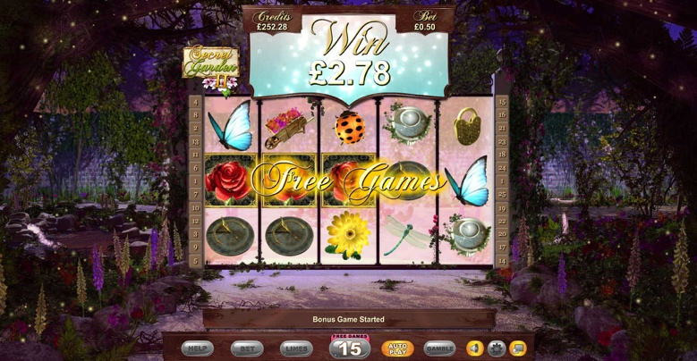
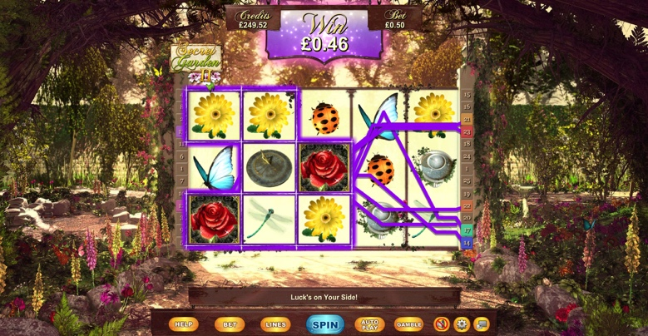

Game Properties & Features

Properties
Versions | Standalone, Mini, Mobile
RTP (%) | 95
Number of Reels | 5
Number of Lines | 25
Min. Bet | 1 credit
Max Bet | 1,250 credits
Game Play | Hard
Volatility | High
Hit Rate playing 1 line | 1 in 24.8
Combined Feature Hit Rate | 1 in 134.7
Default Bet | 2 credits/line playing 25 lines
Supports Free Spins | Yes
Recommended Categories | - Festive/Seasonal – Spring  - Big Wins/Volatile  - Flowers, Fruit & Food
Features
Free Spins | Up to 25
Substitute | Rose Symbol doubles prizes
Bonus Round Feature | Triggered by 3 or more Watering Cans

