Game Information for Native Casino App

Introduction
This document aims to capture game information and images for the Native Casino app. Please fill out all the yellow boxes.
This document is required for each game.

General information

Game name
What is the name of your game and the translation to Simplified Chinese? Include a trade mark if applicable.
English | Secret Garden
Simplified Chinese | 秘密花园
Traditional Chinese | 秘密花園
Japanese | シークレットガーデン
Korean | 비밀 정원
Malay | Taman Rahsia
Spanish | Jardín Secreto

Game code
What is the game code?
pop_secretgarden_eye

Winning lines or ways (slot games only)
How many winning lines or ways does your game have?
25 lines

Jackpot
Are jackpots supported in your game? If so, state the jackpot identifier.
Via another game code yes – but this game code is for the non jackpot version

Bet per lines
What is the default bet per line ranges? Please provide in different currencies if such information is available
GBP|EUR|USD [ 1, 2, 3, 4, 5, 6, 8, 10, 15, 20, 25, 30, 40, 50, 100, 200 ]

Game descriptions
Provide a description of your game in a few sentences for all the lobby languages:
Languages | Description
English (International) | Welcome to the secret garden! Get ready for an enchanting time online, with reels filled with ladybugs, sunflowers, chirping birds, dragonflies and more. But you’ll have to promise not to tell… Secret Garden Slots is one of the best online slot games, and is full of magical bonuses, FREE spins and Wilds, giving you loads of chances to win. So, what do you say, are you ready to find out what’s waiting for you when you enter the garden? Play Secret Garden Slots today – you won’t regret it!
Chinese Simplified | 欢迎来到秘密花园！沉浸在满是瓢虫、向日葵、啁啾鸟、蜻蜓和各种动植物的卷轴游戏中，在线度过令人陶醉的美妙时光。不过，您必须保证不能透露……秘密花园是最棒的在线老虎机游戏之一，也不能让别人知道这个游戏里有数不尽的神奇奖励、免费旋转次数和白百搭图案，将带来大量赢取彩金的机会。怎么样？准备好进入花园探索其中的奥秘了吗？今天立即体验秘密花园——您一定不会后悔！
Chinese Traditional | 歡迎來到秘密花園！準備好體驗一段迷人的線上歡樂時光了嗎，這款老虎機遊戲捲軸上有瓢蟲、向日葵、蜻蜓還有嘰喳的鳥兒。但你必須保守好這個秘密...《秘密花園》老虎機遊戲是最棒的線上老虎機遊戲之一，充斥著魔法獎勵、免費旋轉和百搭圖案玩法，助你輕鬆獲勝。怎麼樣，想進入花園一探究竟，看看有什麼在等著你嗎？立即開始遊玩《秘密花園》吧——不容錯過的老虎機遊戲！
Japanese | シークレットガーデンにようこそ！テントウムシやヒマワリ、さえずる鳥、トンボなどに溢れた魅力的なオンライン時間に準備しましょう。ですが、誰にも言わないと約束してください...シークレットガーデンスロットは、一流のオンラインスロットゲームの1つです。マジカルボーナスやフリースピン、ワイルドなどが勝つチャンスを大幅に高めてくれています。さぁ、どうしますか？ガーデンで待ち受けるものに対する心構えはできましたか？今すぐシークレットガーデンスロットをプレイしましょう - 絶対に後悔はしません！
Korean | 비밀의 정원에 오신 것을 환영합니다! 무당 벌레, 해바라기, 짹짹거리는 새, 잠자리 등으로 가득 찬 릴들로, 온라인 상에서 매혹적인 시간을 준비하십시오. 그러나 비밀의 정원 슬롯은 최고의 온라인 슬롯 게임들 중 하나이며, 마법의 보너스, 무료 스핀 및 와일드들로 가득하여, 많은 승리를 거둘 수 있다는 비밀...을 말하지 않겠다는 약속을 해야 합니다. 자, 정원에 들어갈 때 무엇이 기다리고 있는지 알아낼 준비가 되셨습니까? 오늘 비밀의 정원 슬롯을 즐겨보세요 - 후회하지 않을 것입니다!
Malay | Selamat datang ke taman rahsia! Bersedia untuk mengalami masa yang menakjubkan secara dalam talian, dengan gelendong yang dipenuhi dengan kumbang, bunga matahari, burung-burung yang berkicauan, pepatung dan banyak lagi. Tetapi anda perlu berjanji untuk tidak memberitahu... Secret Garden Slot adalah satu daripada permainan slot dalam talian yang terbaik, dan padat dengan bonus ajaib, putaran dan Liar PERCUMA, memberi anda banyak peluang untuk menang. Jadi, apa lagi, adakah anda telah bersedia untuk mengetahui apa yang menunggu anda apabila anda memasuki taman tersebut? Main Secret Garden Slot hari ini – anda tidak akan menyesal!
Spanish | ¡Te damos la bienvenida al jardín secreto! Prepárate para una encantadora experiencia, con rodillos llenos de mariquitas, girasoles, pájaros, libélulas y más. Pero tendrás que prometer guardar el secreto ... Secret Garden Slots es una de las mejores tragaperras en línea, y está llena de bonos mágicos, giros GRATIS y comodines, que te brindan muchas oportunidades de ganar. Entonces, ¿qué dices? ¿Estás listo para descubrir lo que te espera al entrar al jardín? Juega a las tragaperras Secret Garden hoy, ¡no te arrepentirás!

Images
Note: the assets should be placed in the folders which have the following structure:
- icons with game names should be placed here: games\<game_code>\icons\icons_with_game_names\

Screenshots
The following screenshots are required on mobile in landscape. In case game is available in Portrait only, then screenshots in Portrait (461 x 819) should be provided.
Image type | Screenshot name | Dimensions | Format
Main game in English | screen_<game_code>_main | 819 x 461 | PNG
Significant win in English | screen_<game_code>_big_win | 819 x 461 | PNG
Bonus scene in English | screen_<game_code>_bonus | 819 x 461 | PNG

Game icons
The following game icons are required:
Image Name | Dimensions | Format | Where used in app | Screenshot
<game_code>_icon_5x5 | 240 x 240 | PNG | Quick Switch between games feature | 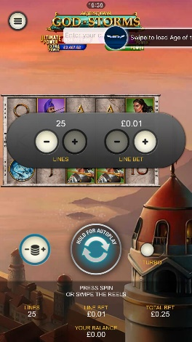
<game_code>_icon_10x10 | 540 x 540 | PNG | Main WL layout: game tiles icons in Lobby, on Game Advisor, Broken games etc. | 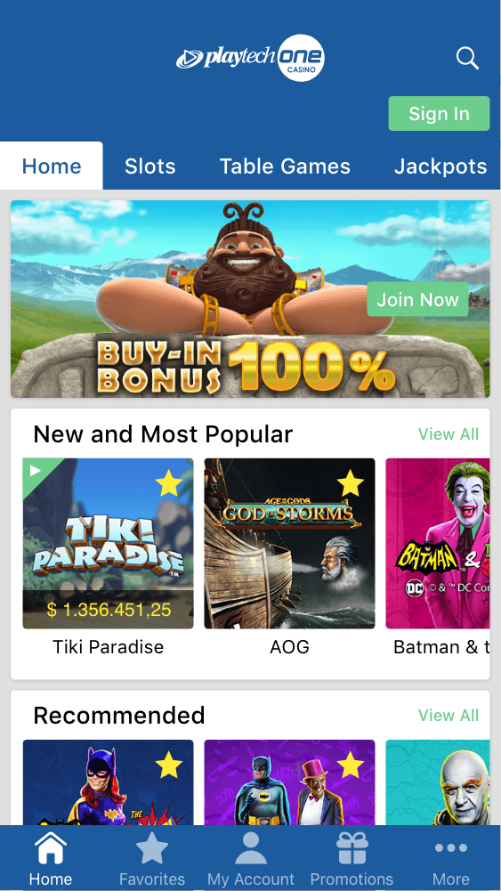  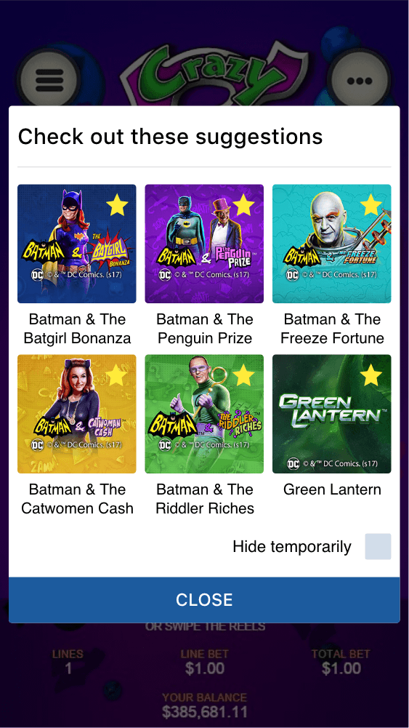
<game_code>_icon_30x5 | 1104 x 336 | PNG | Game Info screen header for tablets | 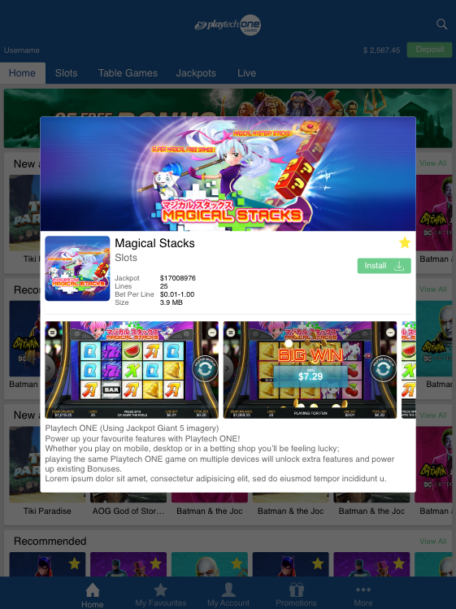
<game_code>_icon_30x10 | 1788 x 540 | PNG | My Favourites screen | 