SECRET GARDEN

Short Description

Unlock the golden gate to your fortune in this secret garden full of magical delights! Discover secret treasures with the sparkling gold key locks scattered across this enchanting 25-line, 5 reel slot game. Win big in your own private magical garden!

Marketing Materials

The materials can be downloaded from [here](https://files.eyecon.com/index.php/s/OHVUD3R4TVd7K3P)

Screenshots

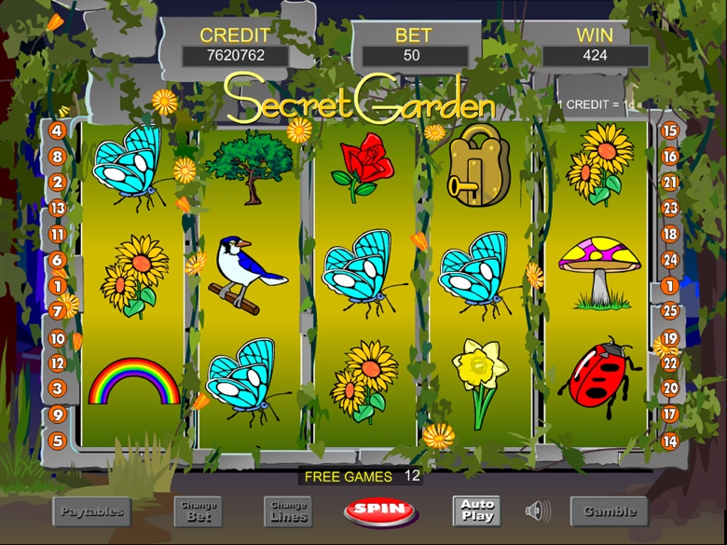

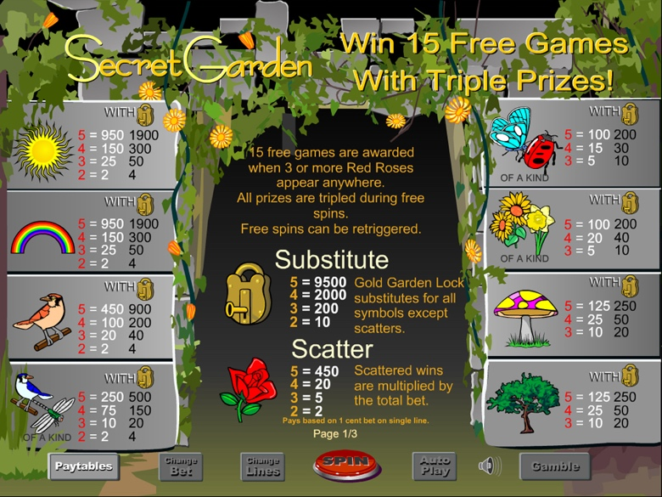

Game Properties & Features

|  |  |
| --- | --- |
| **Properties** | |
| Versions | Standalone, Mini, Mobile |
| RTP (%) | 95 |
| Number of Reels | 5 |
| Number of Lines | 25 |
| Min. Bet | 1 credit |
| Max Bet | 1250 credits |
| Game Play | Medium |
| Volatility | Medium |
| Hit Rate playing 1 line | 1 in 7.5 |
| Combined Feature Hit Rate | 1 in 113 |
| Default Bet | 1 credit per line |
| Supports Free Spins | Yes |
| Recommended Categories | * Big Wins/Volatile * Fruits, Flowers and Vegetables |
| **Features** | |
| Free Spins | Up to 15 |
| Substitute | Gold Lock Symbol |