SHAMAN’S DREAM

Short Description

Shaman Spirit is the much-anticipated sequel to the ever-popular [**Shaman’s Dream**](http://www.eyecon.com/game/shamans-dream-slots/), giving you a chance to once again discover the spirit of the beast and the wonder of the prairie. Your challenge is to reveal the spirit animals of the totem pole before the full moon rises. Double your prize when the female spirit appears and win up to 15 FREE spins when you see three warrior wolf symbols appear. This is an exciting 25 line/5 reel slot game, with a strong maths model which is certain to capture the imagination of new and experienced players alike. Be one with the Shaman Spirit.

Marketing Materials

The materials can be downloaded from [here](https://files.eyecon.com/index.php/s/72FOxzKV5AyG4Xp)

Screenshots

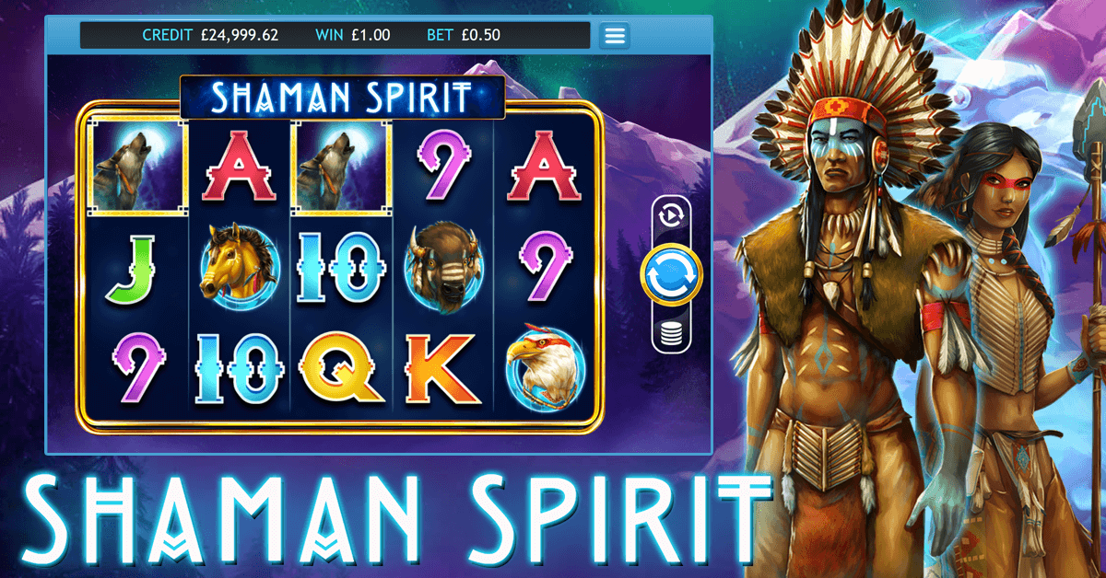

Game Properties & Features

|  |  |
| --- | --- |
| **Properties** | |
| Versions | Standalone, Mini, Mobile |
| RTP (%) | 95 |
| Number of Reels | 5 |
| Number of Lines | 25 |
| Min. Bet | 1 credit |
| Max Bet | 50 credits |
| Game Play | Medium |
| Volatility | Medium |
| Hit Rate playing 1 line | 1 in 7.5 |
| Combined Feature Hit Rate | 1 in 113 |
| Default Bet | 1 credit per line |
| Supports Free Spins | Yes |
| Recommended Categories | * Adventure * Fantasy |
| **Features** | |
| Free Spins | Up to 25 |
| Substitute | Prizes are doubled |