Game Information for Native Casino App

Introduction
This document aims to capture game information and images for the Native Casino app. Please fill out all the yellow boxes.
This document is required for each game.

General information

Game name
What is the name of your game and the translation to Simplified Chinese? Include a trade mark if applicable.
English | Shopping Spree
Simplified Chinese | 疯狂购物
Traditional Chinese | 瘋狂購物
Japanese | ショッピング祭り
Korean | 쇼핑 스프리
Malay | Membeli-belah tanpa kawalan
Spanish | Frenesí de compras

Game code
What is the game code?
pop_shppngspr_eye

Winning lines or ways (slot games only)
How many winning lines or ways does your game have?
25 Line

Jackpot
Are jackpots supported in your game? If so, state the jackpot identifier.
Via another game code yes – but this game code is for the non jackpot version

Bet per lines
What is the default bet per line ranges? Please provide in different currencies if such information is available
GBP|EUR|USD [ 1, 2, 3, 4, 5, 6, 8, 10, 15, 20, 25, 30, 40, 50, 100, 200 ]

Game descriptions
Provide a description of your game in a few sentences for all the lobby languages:
Languages | Description
English (International) | Shop ‘til you drop and win big when you play Shopping Spree Slots! Shopping has never been more fun or more rewarding! The reels are filled with everything you could want and more including fabulous shoes, lipstick, jewellery, presents and some great sales! Additionally, with bonuses, FREE Spins, Wilds and Scatters, you’re bound to win loads, so your Shopping Spree will be 100% guilt-free! Go ahead, you deserve a little pampering.
Chinese Simplified | 畅玩疯狂购物老虎机，尽情享受购物的乐趣，赢取巨额奖金吧!从来没有过像现在这样精彩有趣、物超所值的购物体验！卷轴里装满了您梦寐以求的一切——精美绝伦的鞋子、口红、珠宝、礼物和一些大促销！此外，除了奖金、免费旋转、百搭符号和分散符号您一定会赢得盆满钵满，所以您的疯狂购物之旅一定不会留下任何遗憾!来吧，您应该尽情享受一下。
Chinese Traditional | 暢玩瘋狂購物老虎機，盡情享受購物的樂趣，贏取巨額獎金吧!從來沒有過像現在這樣精彩有趣、物超所值的購物體驗！卷軸裏裝滿了您夢寐以求的一切——精美絕倫的鞋子、口紅、珠寶、禮物和一些大促銷！此外，除了獎金、免費旋轉、百搭符號和分散符號您一定會贏得盆滿缽滿，所以您的瘋狂購物之旅一定不會留下任何遺憾!來吧，您應該盡情享受一下。
Japanese | ショッピング祭りスロットをプレイするときには、大きく倒れるまで買い物をしましょう！ショッピングは今までにないほど楽しく、やりがいがあります。リールには、靴、口紅、ジュエリー、プレゼント、セール品など、欲しいものが満載です。さらに、ボーナス、無料回転、野生と散布を使えば、きっと荷重を勝ち取ることができるので、100%ギルドフリーになります! どうぞ、少し甘やかした方がいいです。
Korean | 쇼핑 스프리 슬롯에서 쓰러질 때까지 쇼핑하고 큰돈을 따보세요! 이보다 재미있고 수익성 높은 쇼핑은 없을 거예요! 고급스러운 신발, 립스틱, 보석, 선물, 놀라운 세일 제품까지 내가 원하는 모든 것이 릴을 가득 채웁니다! 보너스, 프리 스핀, 와일드, 스캐터가 있어 크게 딸 수밖에 없습니다. 쇼핑 스프리에서 죄책감 없는 100% 쇼핑 경험을 즐겨보세요. 나에게 주는 작은 선물이라고 생각하고 지금 바로 시작해보세요.
Malay | Membeli-belah sehingga anda kepenatan dan menang besar apabila anda bermain Slot Membelah-belah tanpa kawalan! Membeli-belah tidak pernah lebih menyeronokkan atau berbaloi! Kekili dipenuhi dengan semua yang anda mahukan dan banyak lagi termasuk kasut yang cantik, gincu, barang kemas, persembahan dan beberapa jualan yang menarik! Selain itu, dengan adanya bonus, Putaran PERCUMA, Liar dan Berselerak, anda pasti akan menang banyak, jadi aktiviti Membeli-belah anda akan 100% bebas rasa bersalah! Teruskan, anda berhak dimanjakan sedikit.
Spanish | ¡Compra hasta desfallecer y gana a lo grande al jugar a la tragaperras de Frenesí de compras! ¡Las compras nunca han sido más divertidas o gratificantes! Los rodillos están repletos de todo lo que podrías desear y más, ¡incluidos zapatos fabulosos, pintalabios, joyas, regalos y algunas grandes rebajas! ¡Además, con las bonificaciones, las tiradas GRATIS, los Wilds y los Scatters, es inevitable que tengas enormes ganancias, así que tu frenesí de compras estará 100 % exento de culpabilidad! Adelante, te mereces un poco de indulgencia.

Images
Note: the assets should be placed in the folders which have the following structure:
- icons with game names should be placed here: games\<game_code>\icons\icons_with_game_names\

Screenshots
The following screenshots are required on mobile in landscape. In case game is available in Portrait only, then screenshots in Portrait (461 x 819) should be provided.
Image type | Screenshot name | Dimensions | Format
Main game in English | screen_<game_code>_main | 819 x 461 | PNG
Significant win in English | screen_<game_code>_big_win | 819 x 461 | PNG
Bonus scene in English | screen_<game_code>_bonus | 819 x 461 | PNG

Game icons
The following game icons are required:
Image Name | Dimensions | Format | Where used in app | Screenshot
<game_code>_icon_5x5 | 240 x 240 | PNG | Quick Switch between games feature | 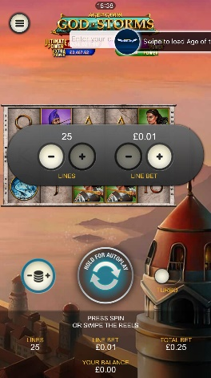
<game_code>_icon_10x10 | 540 x 540 | PNG | Main WL layout: game tiles icons in Lobby, on Game Advisor, Broken games etc. | 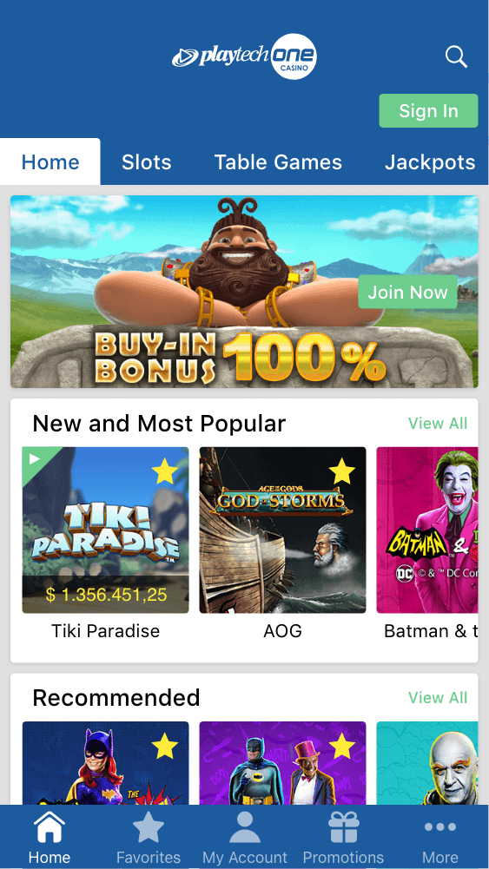  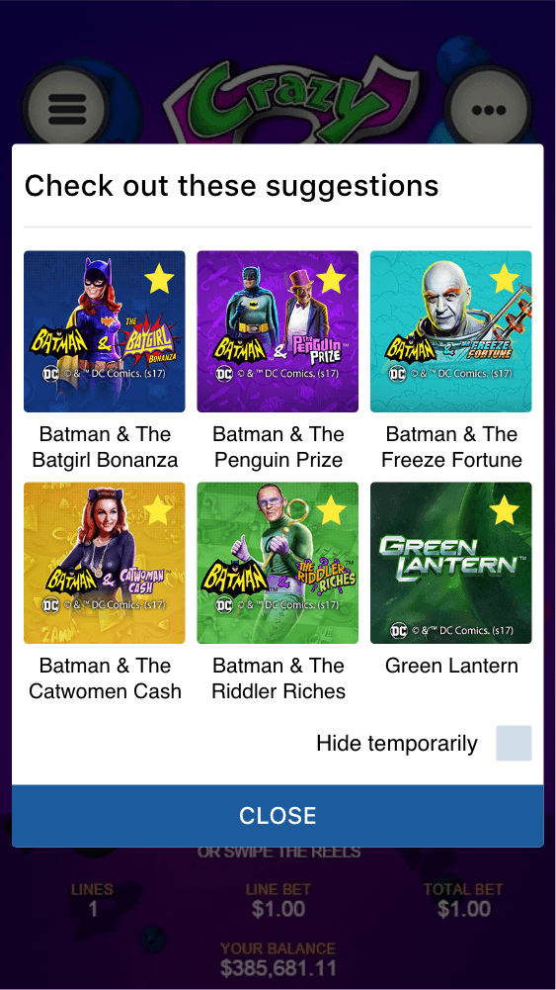
<game_code>_icon_30x5 | 1104 x 336 | PNG | Game Info screen header for tablets | 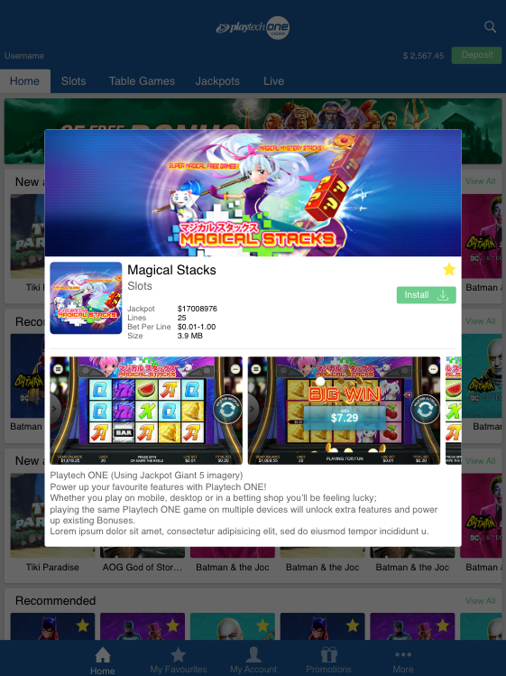
<game_code>_icon_30x10 | 1788 x 540 | PNG | My Favourites screen | 