SHOPPING SPREE

Short Description

Treat yourself to a day at the mall with this fun-filled slot game where everything is on sale! Shop ‘til you drop in free games and let the stylish shopper reward you with even more chances to win big! It’s 25 lines of indulgence over 5 exciting reels! Spoil yourself, you deserve it!

Marketing Materials

The materials can be downloaded from [here](https://files.eyecon.com/index.php/s/MlzqcegXp0KjREt)

Screenshots

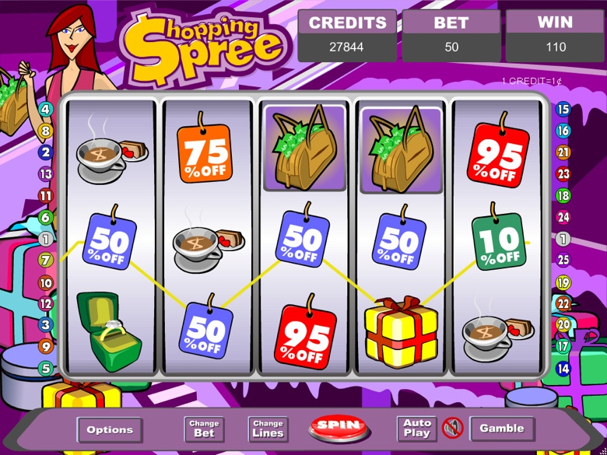

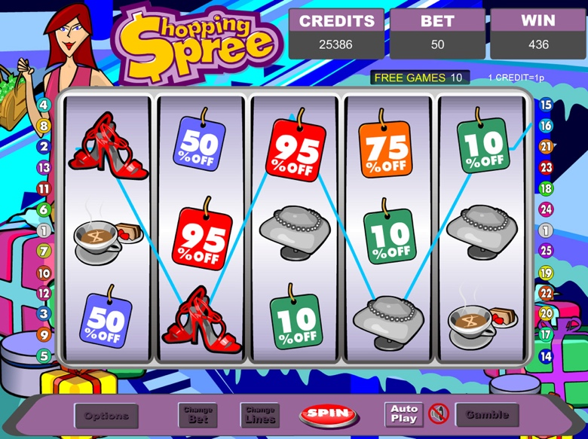

Game Properties & Features

|  |  |
| --- | --- |
| **Properties** | |
| Versions | Standalone, Mini, Mobile |
| RTP (%) | 95 |
| Number of Reels | 5 |
| Number of Lines | 25 |
| Min. Bet | 1 credit |
| Max Bet | 25 credits |
| Game Play | Medium |
| Volatility | Medium |
| Hit Rate playing 1 line | 1 in 7.5 |
| Combined Feature Hit Rate | 1 in 113 |
| Default Bet | 1 credit per line |
| Supports Free Spins | Yes |
| Recommended Categories | * Big Wins/Volatile * Popular * Ladies |
| **Features** | |
| Free Spins | Up to 15 |
| Substitute | Shopper Symbol doubles prizes |