Game Information for Native Casino App

Introduction
This document aims to capture game information and images for the Native Casino app. Please fill out all the yellow boxes.
This document is required for each game.

General information

Game name
What is the name of your game and the translation to Simplified Chinese? Include a trade mark if applicable.
English | Striker Goes Wild
Simplified Chinese | 《热血前锋》
Traditional Chinese | 《狂熱前鋒》
Japanese | ストライカー・ゴーズ・ワイルド
Korean | 열중하는 스트라이커
Malay | Penyerang Mengganas
Spanish | Delantero Total

Game code
What is the game code?
pop_strkrgswld_eye

Winning lines or ways (slot games only)
How many winning lines or ways does your game have?
25 lines

Jackpot
Are jackpots supported in your game? If so, state the jackpot identifier.
Via another game code yes – but this game code is for the non jackpot version

Bet per lines
What is the default bet per line ranges? Please provide in different currencies if such information is available
GBP|EUR|USD [ 1, 2, 3, 4, 5, 6, 8, 10, 15, 20, 25, 30, 40, 50, 100, 200 ]

Game descriptions
Provide a description of your game in a few sentences for all the lobby languages:
Languages | Description
English (International) | The ref blows his whistle and the game is underway. With Striker Goes Wild! you can feel the excitement like never before, as two rival strikers vie to be the best and you spin to win. The trick feature creates a pattern of Wilds which can turn non-paying lines into winning lines. Sliding tackles, bicycle kicks and headers are all there, so get ready to shout GOAL!!
Chinese Simplified | 裁判吹响了手中的哨子，比赛正式拉开帷幕。在《热血前锋》中感受前所未有的刺激体验，两个前锋血脉贲张展开一场巅峰对决，而您只需旋转一下赢取奖励。在技能游戏中出现的百搭图案，可将非赔付线变成中奖线。铲球、倒钩球、头球样样拿手，准备好射门进球吧！
Chinese Traditional | 裁判一聲哨響，比賽正式拉開帷幕。感受《熱血前鋒》空前未有的刺激體驗，兩隊前鋒激烈對戰爭奪王者之冕，而您只需按下旋轉贏取獎勵。在球術遊戲中出現的百搭圖案，可將非賠付線轉變為中獎線。鏟球、倒鉤球、頭球無所不精，準備好射門進球吧！
Japanese | レフリーが笛を吹き、ゲームが始まります。ストライカー・ゴーズ・ワイルド！では、これまで感じたことのない興奮を感じることができます。2人のライバルストライカーが頂点を目指して競い合い、あなたは勝利のためにスピンするのです。トリックフィーチャーでは、負けラインを勝ちラインに変えてしまうワイルドのパターンを作りだします。スライディングタックル、バイシクルキック、ヘッダーはすべて用意されていますのでゴールと叫ぶ準備をしていてください！！
Korean | 심판이 휘파람을 불고 게임이 진행됩니다. 스트라이커와 함께 열중해 보세요! 두 명의 라이벌 스트라이커가 최고가 되기 위해 경쟁하고 귀하는 승리하기 위해 스핀을 회전시키면서 전에 느끼지 못했던 흥분을 느낄 수 있습니다. 트릭 기능은 지불하지 않는 라인을 승리 라인으로 바꿀 수 있는 와일드 패턴을 생성합니다. 슬라이딩 태클, 바이시클 킥 및 헤더가 모두 있으므로, 골을 외칠 준비를하십시오!!
Malay | Pengadil meniup wiselnya dan permainan itu dimulakan. Dengan Penyerang Mengganas! Anda boleh rasakan keterujaannya yang tidak pernah dirasai sebelum ini, apabila dua penyerang berusaha untuk menjadi yang terbaik dan anda memutarkan untuk menang. Ciri helah ini mewujudkan corak Liar yang boleh mengubah baris tidak bayar kepada baris menang. Dengan takel yang meluncur, tendangan basikal dan tandukan, jadi bersedialah untuk meneriak GOL!!
Spanish | El árbitro sopla su silbato y el partido comienza. Con Delantero Total puedes sentir la emoción futbolística como nunca antes, con dos delanteros que luchan por ser los mejores mientras giras y giras para ganar. La función «truco» crea un patrón de Comodines que puede convertir las líneas sin premio en líneas premiadas. Entradas, chilenas, remates de cabeza... está todo ahí, ¡¡así que prepárate para gritar GOL!!

Images
Note: the assets should be placed in the folders which have the following structure:
- icons with game names should be placed here: games\<game_code>\icons\icons_with_game_names\

Screenshots
The following screenshots are required on mobile in landscape. In case game is available in Portrait only, then screenshots in Portrait (461 x 819) should be provided.
Image type | Screenshot name | Dimensions | Format
Main game in English | screen_<game_code>_main | 819 x 461 | PNG
Significant win in English | screen_<game_code>_big_win | 819 x 461 | PNG
Bonus scene in English | screen_<game_code>_bonus | 819 x 461 | PNG

Game icons
The following game icons are required:
Image Name | Dimensions | Format | Where used in app | Screenshot
<game_code>_icon_5x5 | 240 x 240 | PNG | Quick Switch between games feature | 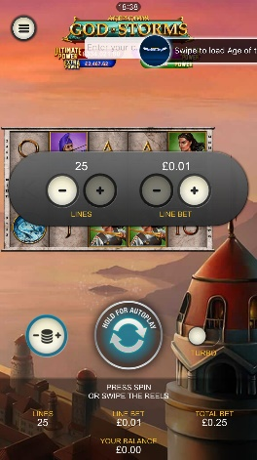
<game_code>_icon_10x10 | 540 x 540 | PNG | Main WL layout: game tiles icons in Lobby, on Game Advisor, Broken games etc. | 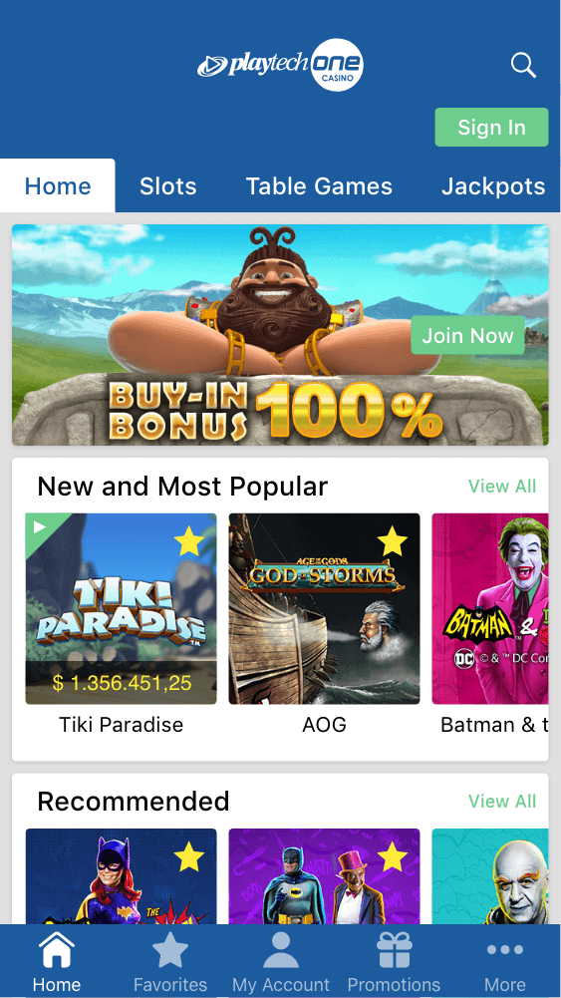  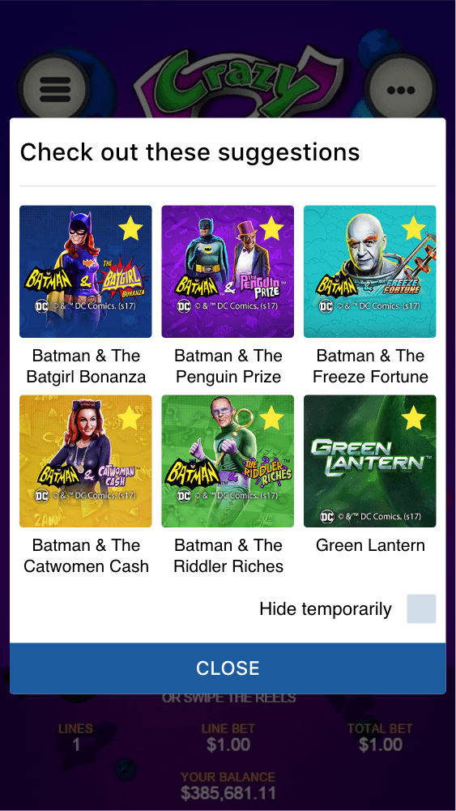
<game_code>_icon_30x5 | 1104 x 336 | PNG | Game Info screen header for tablets | 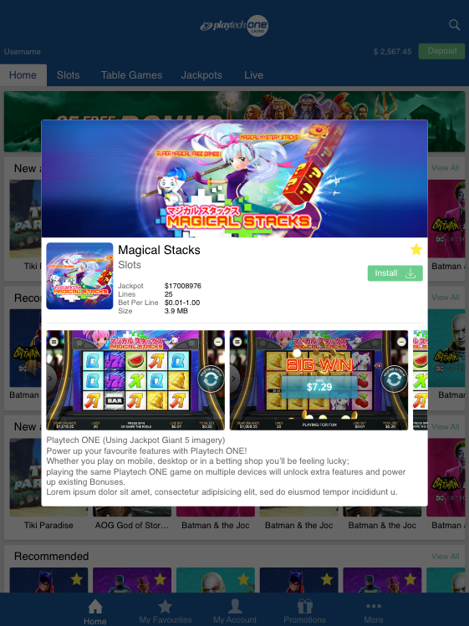
<game_code>_icon_30x10 | 1788 x 540 | PNG | My Favourites screen | 