SUGAR TRAIN XMAS

Short Description

Jump om board the Sugar Train Sleigh for your ticket to sweet success this Xmas! 25 mouth-watering lines across 5 delicious reels delight the senses to win you a sweet fortune! Santa has come early, delivering sweet rewards with all your favourite Xmas treats and delicious prizes! Get back on the Sugar Train track this Xmas!

Marketing Materials

The materials can be downloaded from [here](https://files.eyecon.com/index.php/s/cAls6kUULOCe6aD)

Screenshots

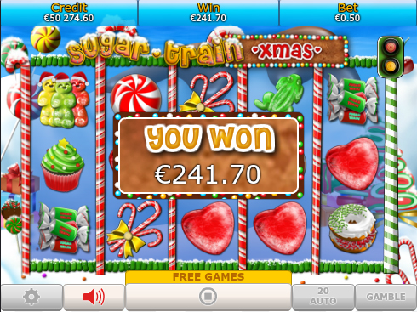

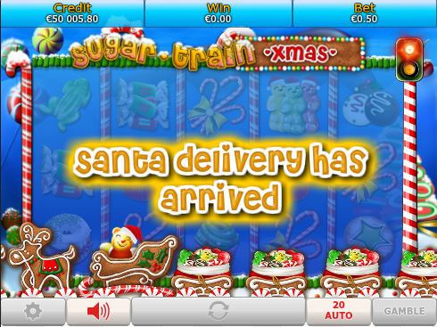

Game Properties & Features

|  |  |
| --- | --- |
| **Properties** | |
| Versions | Standalone, Mini, Mobile |
| RTP (%) | 95 |
| Number of Reels | 5 |
| Number of Lines | 25 |
| Min. Bet | 1 credit |
| Max Bet | 50 credits |
| Game Play | Medium |
| Volatility | Medium |
| Hit Rate playing 1 line | 1 in 25 |
| Combined Feature Hit Rate | 1 in 72 |
| Default Bet | 1 credit per line |
| Supports Free Spins | Yes |
| Recommended Categories | * Adventure * Cute Animals |
| **Features** | |
| Free Spins | Up to 25 |
| Substitute | Gummybear Symbol doubles prizes |
| Prize Pick Feature | Chimneys award up to 100X the triggering bet |