SUGAR TRAIN

Short Description

Jump on board the Sugar Train for your ticket to sweet success in this exciting new slot game! 25 mouth watering lines across 5 delicious reels delight the senses to win you a sweet fortune! Ride the rainbow with the gummy bears and slide into a world full of delightful riches that are yours for the taking! All aboard the sugar train to Candy Land riches!

Marketing Materials

The materials can be downloaded from [here](https://files.eyecon.com/index.php/s/T5dP8egLRX2cnv1)

Screenshots

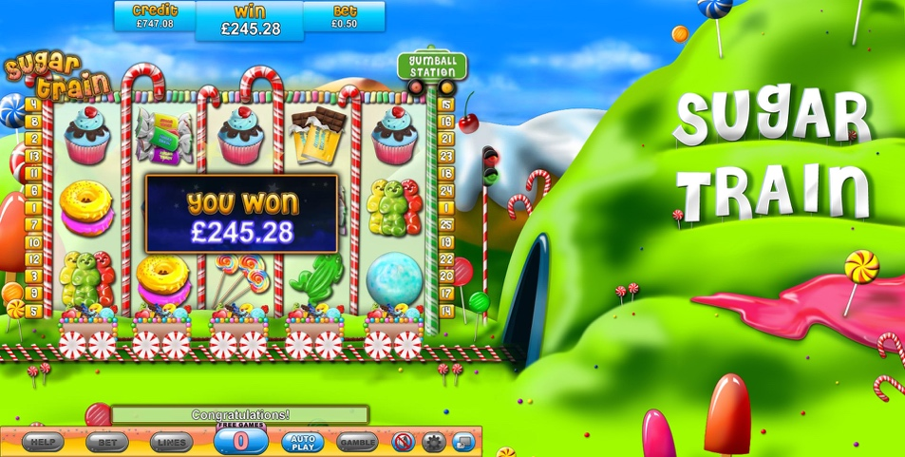

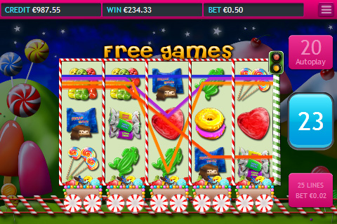

Game Properties & Features

|  |  |
| --- | --- |
| **Properties** | |
| Versions | Standalone, Mini, Mobile |
| RTP (%) | 95 |
| Number of Reels | 5 |
| Number of Lines | 25 |
| Min. Bet | 1 credit |
| Max Bet | 50 credits |
| Game Play | Medium |
| Volatility | High |
| Hit Rate playing 1 line | 1 in 25.2 |
| Combined Feature Hit Rate | 1 in 71.7 |
| Default Bet | 1 credit per line |
| Supports Free Spins | Yes |
| Recommended Categories | * Popular * Food & Fun |
| **Features** | |
| Free Spins | Up to 25 |
| Substitute | Prizes are doubled |
| Prize Pick Feature | Up to 500X your total bet |