SUNNY MONEY

Short Description

Make a splash this season in the new sizzling-hot mini slot, Sunny Money! Let your fortunes shine in the radiant Prize Pick Feature and catch some waves with 8 Free Games! It’s a 9-line, 3-reel slot bound to keep you hot, hot, hot!

Marketing Materials

The materials can be downloaded from [here](https://files.eyecon.com/index.php/s/s8QLTPv0AMAo9fr)

Screenshots

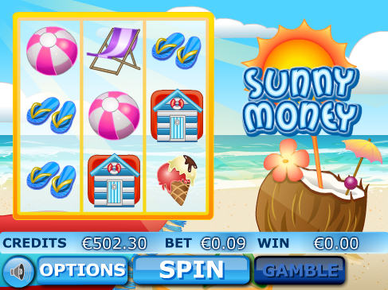

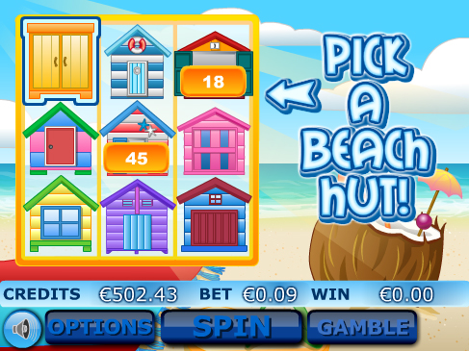

Game Properties & Features

|  |  |
| --- | --- |
| **Properties** | |
| Versions | Mini, Mobile |
| RTP (%) | 95 |
| Number of Reels | 3 |
| Number of Lines | 9 |
| Min. Bet | 1 credit |
| Max Bet | 900 credits |
| Game Play | Hard |
| Volatility | High |
| Hit Rate playing 1 line | 1 in 16 |
| Combined Feature Hit Rate | 1 in 79 |
| Default Bet | 10 credits/line playing 9 lines |
| Supports Free Spins | Yes |
| Recommended Categories | * Festive/Seasonal – Summer * Big Wins/Volatile |
| **Features** | |
| Free Spins | Up to 7 |
| Substitute | Sunny Money Logo |
| Prize Pick Feature | Triggered by 3 Beach Hut Symbols |