TIN TOWN

Short Description
Discover a treasure-trove of excitement in Robot town! Build your fortune spinning through 25-lines of high-tech gizmos and gadgets across 5 technologically advanced reels! Dance with the Dancebot and play with the adorable Dogbot in this adventurous and outrageously fun slot game!

Marketing Materials
The materials can be downloaded from here
Screenshots
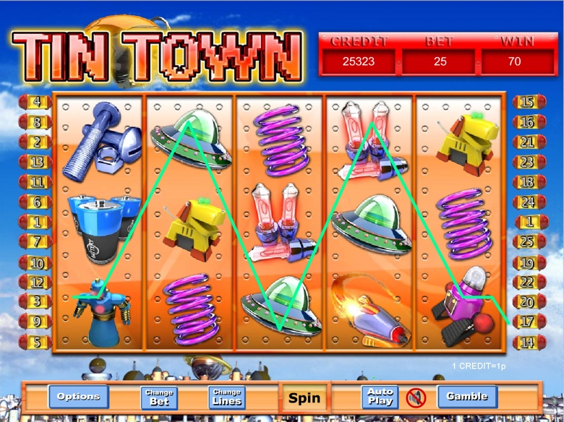
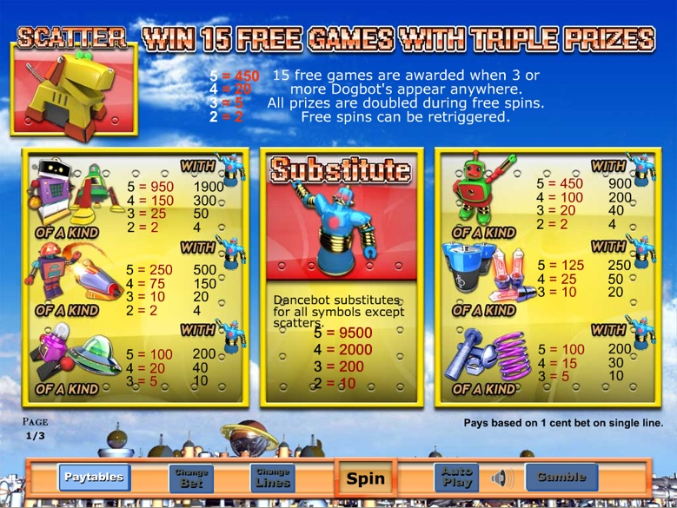

Game Properties & Features

Properties
Versions | Standalone
RTP (%) | 95
Number of Reels | 5
Number of Lines | 25
Min. Bet | 1 credit
Max Bet | 1,250 credits
Game Play | Medium
Volatility | Low
Hit Rate playing 1 line | 1 in 7
Combined Feature Hit Rate | 1 in 86
Default Bet | 2 credits/line playing 25 lines
Supports Free Spins | Yes
Recommended Categories | - Action/Adventure/Sci-Fi
Features
Free Spins | Up to 100
Substitute | Dancebot Symbol
Bonus Round | Triggered by 3 or more Dogbots

