TWINKLE

Short Description

Come on an action adventure ride and help Twinkle save her captured Fairy friends aboard the Pirate ship. 25 lines of Fairytastic fun on the open seas. Get 3 or more Jars to trigger the Prize Pick to save the captured Fairies and get great rewards. Get 3 or more Twinkles to trigger 25 Free Games. Come and play Twinkle now and unleash your inner Fairy.

Marketing Materials

The materials can be downloaded from [here](https://files.eyecon.com/index.php/s/0iHr6stDJ8HyJrf).

Screenshots

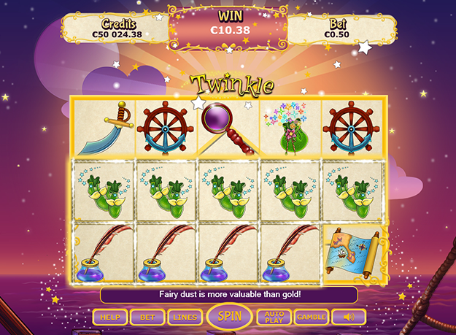

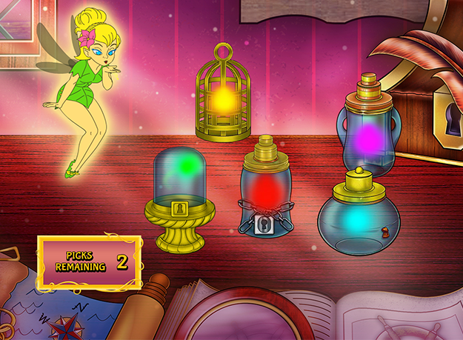

Game Properties & Features

|  |  |
| --- | --- |
| **Properties** | |
| Versions | Standalone, Mobile, Embedded |
| RTP (%) | 93 (JP), 95 |
| Number of Reels | 5 |
| Number of Lines | 25 |
| Min Bet | 1 credit |
| Max Bet | 50 credits |
| Game Play | Hard |
| Volatility | High |
| Hit Rate playing 1 line | 1 in 24.8 |
| Combined Feature Hit Rate | 1 in 134.7 |
| Default bet | 2 credits per line |
| Supports Free Spins | Yes |
| Recommended Categories | * Adventure * Huge Wins * Fantasy |
| **Features** | |
| Free Spins | Up to 15 |
| Substitute | Doubles the prize |
| Prize Pick Feature | Up to 100X the prize |