Unicorn Bliss

Short Description

**Summary**

Unicorn Bliss Slots is bright and colourful, full of beautiful flowers, chirping birds and magical unicorns. Unicorn Bliss will instantly put a smile on your face as the reels get spinning and the wins start coming in. It’s a guaranteed good time – absolutely blissful, if you will. Don’t miss another minute of play. Enjoy rewarding bonus features and more. Good luck!

**Formats**

* Stand Alone
* Embedded
* Mobile

**Recommended categories**

* Animal Slots
* Cute Slots
* Fantasy

Marketing Materials

The materials can be downloaded from [here](https://files.eyecon.com/index.php/s/vxsjgDkzKaowJFo)

Screenshot

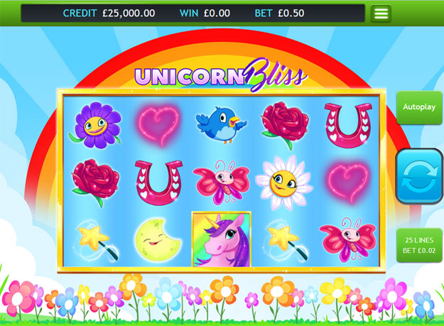

Game Properties & Features

|  |  |
| --- | --- |
| **Properties** | |
| Versions | Standalone, Mini, Mobile |
| RTP (%) | 95 |
| Number of Reels | 5 |
| Number of Lines | 25 |
| Min. Bet | 1 credit |
| Max Bet | 1250 credits |
| Game Play | Medium |
| Volatility | Medium |
| Hit Rate playing 1 line | 1 in 7.5 |
| Combined Feature Hit Rate | 1 in 113 |
| Default Bet | 1 credit per line |
| Supports Free Spins | Yes |
| **Features** | |
| Free Spins | Up to 15 |
| Substitute | Unicorn Symbol |