Game Information for Native Casino App

Introduction
This document aims to capture game information and images for the Native Casino app. Please fill out all the yellow boxes.
This document is required for each game.

General information

Game name
What is the name of your game and the translation to Simplified Chinese? Include a trade mark if applicable.
English | Very Merry Christmas
Simplified Chinese | 圣诞快乐
Traditional Chinese | 聖誕快樂
Japanese | ベリーメリークリスマス！
Korean | 베리 메리 크리스마스
Malay | Selamat Hari Natal!
Spanish | Unas muy felices vacaciones

Game code
What is the game code?
pop_vrmrrchrstms_eye

Winning lines or ways (slot games only)
How many winning lines or ways does your game have?
25 Line

Jackpot
Are jackpots supported in your game? If so, state the jackpot identifier.
Via another game code yes – but this game code is for the non jackpot version

Bet per lines
What is the default bet per line ranges? Please provide in different currencies if such information is available
GBP|EUR|USD [ 1, 2, 3, 4, 5, 6, 8, 10, 15, 20, 25, 30, 40, 50, 60, 80, 100, 200 ]

Game descriptions
Provide a description of your game in a few sentences for all the lobby languages:
Languages | Description
English (International) | Ho Ho Ho! It’s never too early or late to celebrate your favourite holiday! Very Merry Christmas Slots’ reels are filled with loads of gifts from Santa, including teddy bears, rocking horses, wooden trains and surprise unwrapped boxes – what do you think is inside? Whether you’ve been naughty or nice, there’s something exciting waiting for you in Very Merry Christmas Slots! Cuddle up with a hot cup of cocoa, or maybe a nice glass of eggnog, and play today!
Chinese Simplified | 嗬嗬嗬！只要是庆祝你最喜欢的节日，永远都不会太早或太晚！圣诞快乐老虎机捲轴裡装满了圣诞老人的礼物，有泰迪熊、摇摇马、木制小火车和惊喜礼盒——你猜猜裡面有什么？无论你是顽皮可爱还是乖巧懂事，圣诞快乐老虎机都有令你兴奋不已的惊喜等着你！抱着一杯热可可，或是一杯美味的蛋酒，马上开玩吧！
Chinese Traditional | 嗬嗬嗬！只要是慶祝你最喜歡的節日，永遠都不會太早或太晚！聖誕快樂老虎機捲軸裡裝滿了聖誕老人的禮物，有泰迪熊、搖搖馬、木製小火車和驚喜禮盒——你猜猜裡面有什麼？無論你是頑皮可愛還是乖巧懂事，聖誕快樂老虎機都有令你興奮不已的驚喜等著你！抱著一杯熱可可，或是一杯美味的蛋酒，馬上開玩吧！
Japanese | ハイ、ハイ、ハイ！一番大好きなホリデーを祝うのに、遅すぎることも早すぎることもありません！ベリーメリークリスマススロットのリールには、サンタからの沢山のプレゼントが溢れます。テディベア、揺り木馬、木製の列車、そしてサプライズのボックスを開きましょう - 何があるかな？いたずらっ子にも良い子にも、ベリーメリークリスマススロットにはワクワクするモノが待っています！ホットココアや、美味しいエグノッグを抱えて温まりながら、さあ、プレイしましょう！
Korean | 호 호 호! 최고의 연휴를 기념하기에는 너무 이른 때도 늦은 때도 없습니다. 베리 메리 크리스마스 슬롯 릴에는 테디 베어, 흔들 목마, 나무 기차, 깜짝 선물까지 산타의 선물이 가득합니다. 안에 무엇이 들어있을까요? 착한 아이든 나쁜 아이든, 베리 메리 크리스마스 슬롯에는 신나는 일이 기다리고 있어요! 코코아 한잔이나 에그노그 한잔과 함께 오늘 바로 플레이해보세요!
Malay | Ho Ho Ho! Ia tidak terlalu awal atau lewat untuk menyambut cuti kegemaran anda! Gulungan Slot Selamat Hari Natal dipenuhi dengan hadiah dari Santa, termasuk beruang teddy, kuda jongket, keretapi kayu dan kotak kejutan berbalut - apa yang ada di dalam? Sama ada anda nakal atau baik, ada benda menarik yang menanti anda dalam Slot Selamat Hari Natal! Santai dengan secawan koko panas, mungkin secawan eggnog yang sedap, dan main hari ini!
Spanish | ¡Jo, jo, jo! ¡Nunca es demasiado pronto para celebrar tu fiesta favorita! Los rodillos de la tragaperras Unas muy felices vacaciones están cargados con montones de regalos de Santa, incluidos osos de peluche, caballitos balancín, trenes de madera y cajas sorpresa sin envolver. ¿Qué crees que habrá dentro? ¡No importa si has sido bueno o travieso, habrá algo emocionante esperándote en Unas muy felices vacaciones! ¡Acurrúcate con una taza de chocolate caliente o un buen vaso de ponche de huevo y juega ya!

Images
Note: the assets should be placed in the folders which have the following structure:
- icons with game names should be placed here: games\<game_code>\icons\icons_with_game_names\

Screenshots
The following screenshots are required on mobile in landscape. In case game is available in Portrait only, then screenshots in Portrait (461 x 819) should be provided.
Image type | Screenshot name | Dimensions | Format
Main game in English | screen_<game_code>_main | 819 x 461 | PNG
Significant win in English | screen_<game_code>_big_win | 819 x 461 | PNG
Bonus scene in English | screen_<game_code>_bonus | 819 x 461 | PNG

Game icons
The following game icons are required:
Image Name | Dimensions | Format | Where used in app | Screenshot
<game_code>_icon_5x5 | 240 x 240 | PNG | Quick Switch between games feature | 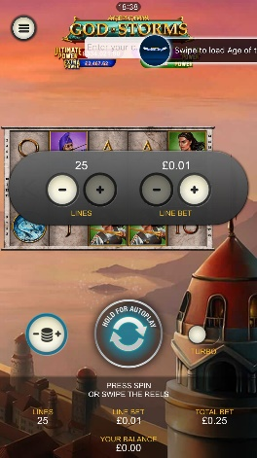
<game_code>_icon_10x10 | 540 x 540 | PNG | Main WL layout: game tiles icons in Lobby, on Game Advisor, Broken games etc. | 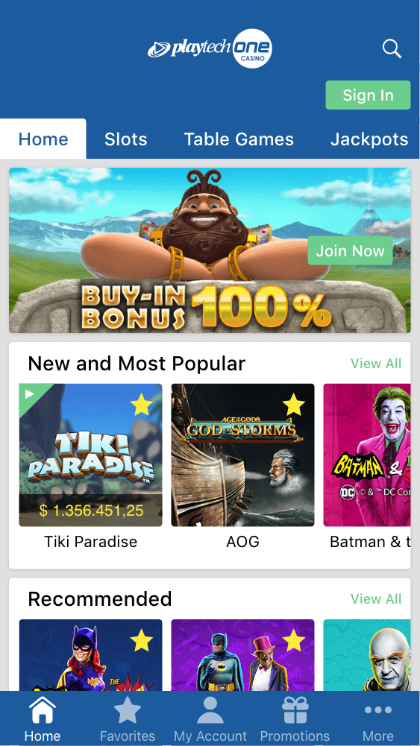  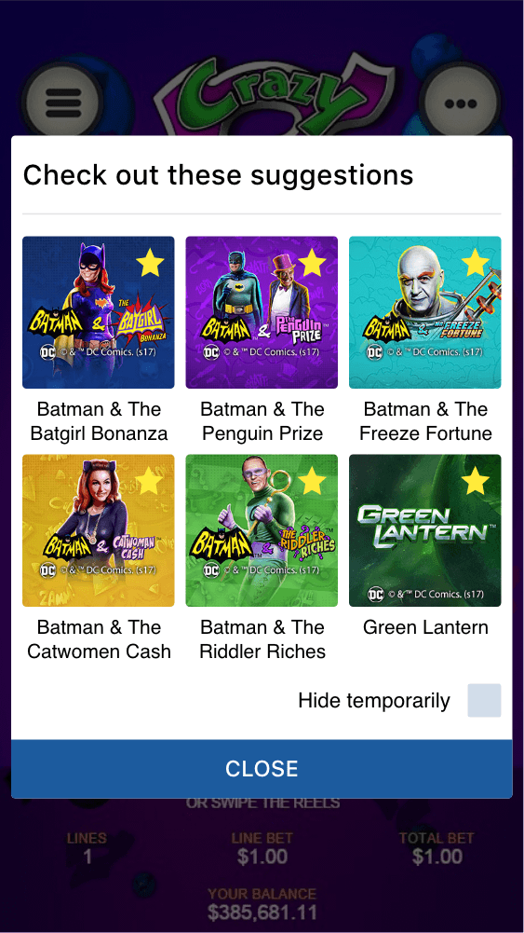
<game_code>_icon_30x5 | 1104 x 336 | PNG | Game Info screen header for tablets | 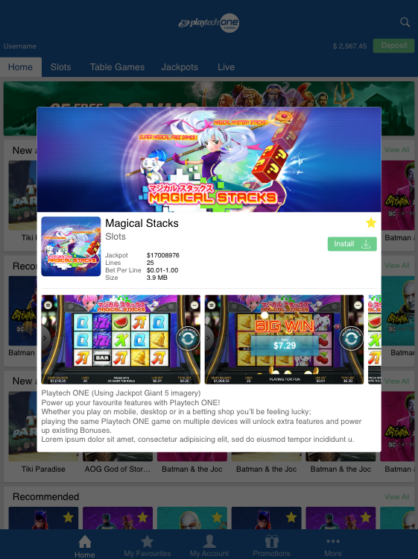
<game_code>_icon_30x10 | 1788 x 540 | PNG | My Favourites screen | 