Game Information for Native Casino App

Introduction
This document aims to capture game information and images for the Native Casino app. Please fill out all the yellow boxes.
This document is required for each game.

General information

Game name
What is the name of your game and the translation to Simplified Chinese? Include a trade mark if applicable.
English | White Wizard Deluxe
Simplified Chinese | 白色巫师豪华版
Traditional Chinese | 白巫師（豪華版）
Japanese | ホワイトウィザードデラックス
Korean | 화이트 위자드 디럭스
Malay | Deluks Wizard Putih
Spanish | Mago Blanco Lujoso

Game code
What is the game code?
pop_whtwzrddlx_eye

Winning lines or ways (slot games only)
How many winning lines or ways does your game have?
100 lines

Jackpot
Are jackpots supported in your game? If so, state the jackpot identifier.
Via another game code yes – but this game code is for the non jackpot version

Bet per lines
What is the default bet per line ranges? Please provide in different currencies if such information is available
GBP|EUR|USD [ 1, 2, 3, 5, 8, 10, 15, 20, 25, 30, 50 ]

Game descriptions
Provide a description of your game in a few sentences for all the lobby languages:
Languages | Description
English (International) | Get ready for an enchanting journey… If you like White Wizard Slots, you’re bound to love White Wizard Deluxe! It has the same 5 reels, but most noteworthy, an extremely generous 100 paylines – it’s magical! The graphics are great, with the White Wizard himself in the background, overlooking your wins. The reels are filled with majestic symbols like Unicorns, Magic Brooms, Spell Books and Crystal Balls, and you’ll enjoy some rewarding bonuses like FREE spins, multipliers and more! So, what do you say? Spin to win today!
Chinese Simplified | 准备开启迷人旅程……如果喜欢《白色巫师》老虎机游戏，那么您一定会爱上《白色巫师豪华版》！该款游戏同样设有 5 个卷轴，但更值得一提的是，游戏中共有 100 条奖金丰厚的赔付线——太神奇了！画面精美，您将看到白色巫师站在游戏背景中，见证您的胜利。卷轴上将出现独角兽、魔术扫帚、咒语书和水晶球等神奇图案。此外，游戏还开放了免费旋转、倍数和其他趣味奖励玩法！现在有何想法？立即旋转，赢取大奖！
Chinese Traditional | 準備好開始一場魔幻的旅程吧...如果你是《白巫師》的狂熱玩家，那這款豪華版的《白巫師》遊戲一定不容錯過！遊戲有 5 個相同的捲軸，但獲勝線高達 100 條——這是法師的魔力！遊戲畫面一流，白巫師本人就在遊戲背景中注視著你的收穫。捲軸中充滿了各種美麗的圖案，包括獨角獸、魔法掃帚、魔法書和水晶球，還有免費旋轉、翻倍獎勵等等各種特色獎勵等著你！怎麼樣？馬上開始遊戲吧！
Japanese | 魅力的な旅の準備をしましょう...ホワイトウィザードスロットが好きな方でしたら、間違いなくホワイトウィザードデラックスも好きになることでしょう！同じ5リールを有していますが、特記すべき点としては太っ腹な100ペイラインを用意しているところです - もはや魔法です！グラフィックも素晴らしいです。ホワイトウィザード自身がバックグラウンドであなたのウィンを見守ってくれます。リールにはユニコーンや魔法の箒、スペルブック、クリスタルボールなどの壮大なシンボルが溢れており、フリースピンやマルチプライヤーなど達成感を感じられるボーナスを獲得することができます。どう思いますか？今すぐスピンして勝利を手にしましょう！
Korean | 매혹적인 여행을 준비하십시오… 화이트 위저드 슬롯을 좋아한다면, 화이트 위저드 디럭스를 좋아하지 않을 수 없습니다! 이것은 동일한 5 릴들 그러나, 가장 주목할만한, 매우 관대한 100 페이 라인들을 가지고 있습니다 – 그것은 황홀합니다! 그래픽들은 훌륭합니다. 배경에 하얀 마법사가 있어, 당신의 승리를 내려다 봅니다. 릴에는 유니콘, 마법 빗자루, 마법서 및 수정 구슬과 같은 장엄한 심벌들로 가득 차 있고, 무료 스핀, 승수 등과 같은 보상있는 보너스들을 즐기게 될 것입니다! 그래, 어떻습니까? 오늘 이기기 위해 스핀을 돌리세요!
Malay | Bersedia untuk melalui perjalanan yang mempesonakan... Jika anda gemarkan Slot White Wizard, anda pasti akan menggemari White Wizard Deluxe! Ia mempunyai 5 gelendong yang sama, tetapi yang paling patut diberikan perhatian, 100 baris bayar yang sangat lumayan – sungguh ajaib! Grafiknya hebat, dengan White Wizard itu sendiri di latar belakang, melihat kemenangan anda. Gelendongnya padat dengan simbol kemegahan seperti Unikorn, Penyapu Ajaib, Buku Mantera dan Bola Kristal, dan anda akan menikmati beberapa bonus yang mengganjarkan seperti putaran, pengganda PERCUMA dan banyak lagi! Jadi, apa kata anda? Putar untuk menang hari ini!
Spanish | ¡Si te gusta la tragaperras White Wizard, seguramente adorarás White Wizard Deluxe! Tiene los mismos 5 rodillos, pero con una notable mejora: 100 líneas de pago extremadamente generosas. ¡Pura magia! Los gráficos son geniales, con el propio Mago Blanco en el fondo observando tus giros ganadores. ¡Los rodillos están llenos de símbolos mágicos, tales como Unicornios, Escobas mágicas, Libros de hechizos y Bolas de cristal. Durante el juego disfrutarás de geniales bonificaciones como giros GRATIS, multiplicadores y más! ¿Entonces qué dices? ¡Gira y empieza a ganar premios sobrenaturales!

Images
Note: the assets should be placed in the folders which have the following structure:
- icons with game names should be placed here: games\<game_code>\icons\icons_with_game_names\

Screenshots
The following screenshots are required on mobile in landscape. In case game is available in Portrait only, then screenshots in Portrait (461 x 819) should be provided.
Image type | Screenshot name | Dimensions | Format
Main game in English | screen_<game_code>_main | 819 x 461 | PNG
Significant win in English | screen_<game_code>_big_win | 819 x 461 | PNG
Bonus scene in English | screen_<game_code>_bonus | 819 x 461 | PNG

Game icons
The following game icons are required:
Image Name | Dimensions | Format | Where used in app | Screenshot
<game_code>_icon_5x5 | 240 x 240 | PNG | Quick Switch between games feature | 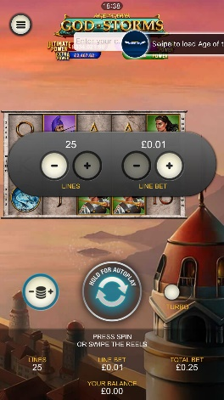
<game_code>_icon_10x10 | 540 x 540 | PNG | Main WL layout: game tiles icons in Lobby, on Game Advisor, Broken games etc. | 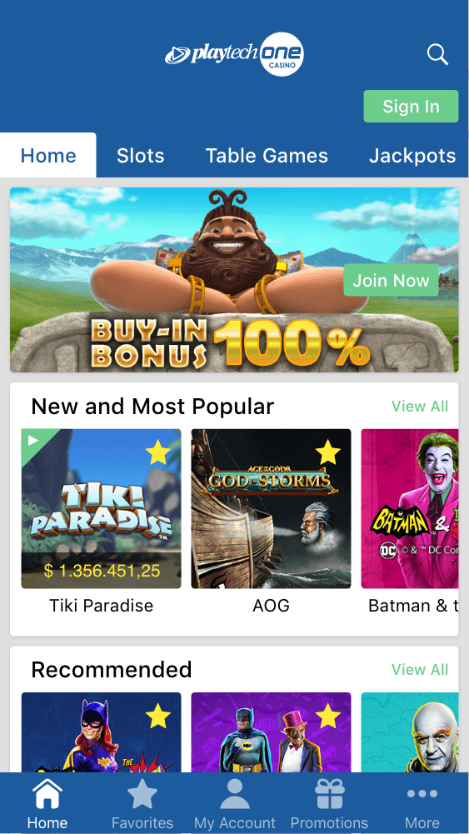  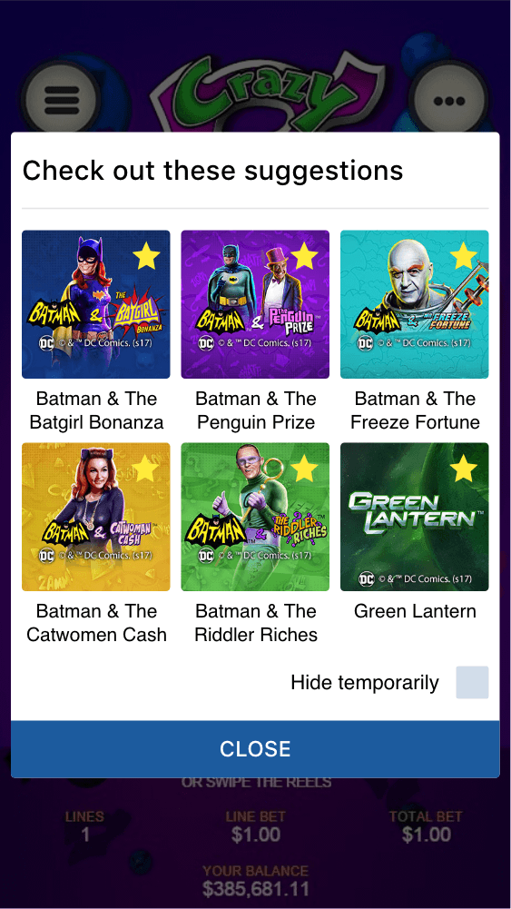
<game_code>_icon_30x5 | 1104 x 336 | PNG | Game Info screen header for tablets | 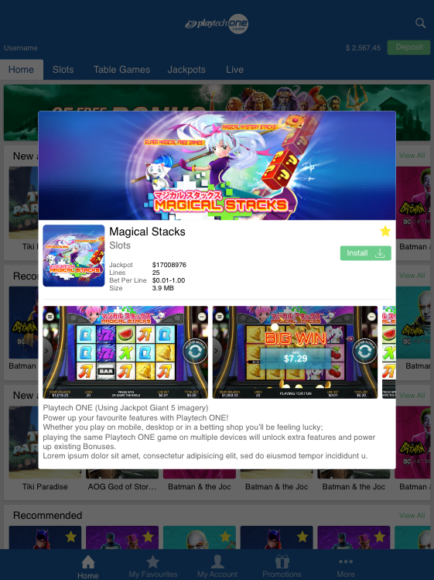
<game_code>_icon_30x10 | 1788 x 540 | PNG | My Favourites screen | 