WHITE WIZARD DELUXE

Short Description

Cast a magic spell and conjure up a sparkling fortune! Magic Dragons and White Wizards enchant the reels in this epic 100-line slot. Triple prizes are triple the fun the White Wizard substitutes in a winning combination. Spellbinding! Up to 25 fun-filled free spins are awarded in the magical Free Games feature. Feel the excitement as the expanding White Wizard grants your every wish!

Marketing Materials

The materials can be downloaded from [here](https://files.eyecon.com/index.php/s/Vr2z7hyjXNfdi8k).

Screenshots

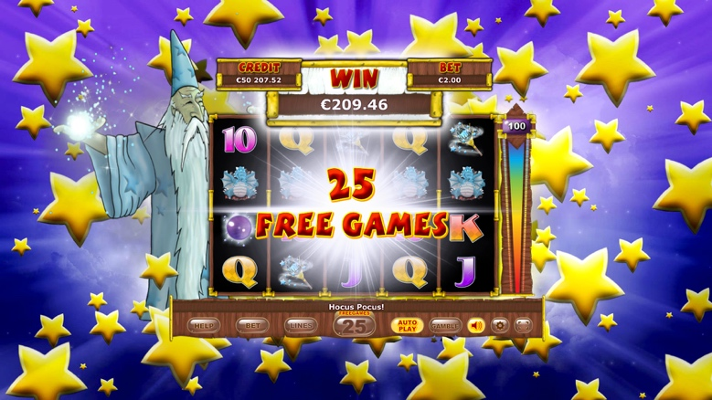

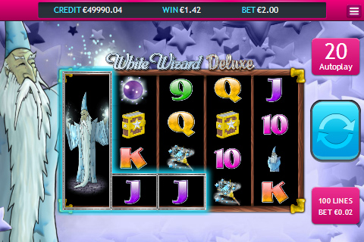

Game Properties & Features

|  |  |
| --- | --- |
| **Properties** | |
| Versions | Standalone, Mobile |
| RTP (%) | 95 |
| Number of Reels | 5 (by 4) |
| Number of Lines | 100! |
| Min. Bet | 1 credit |
| Max Bet | 25 credits |
| Game Play | Medium |
| Volatility | High |
| Hit Rate playing 1 line | 1 in 30.8 |
| Combined Feature Hit Rate | 1 in 133.9 |
| Default Bet | 1 credit per line |
| Supports Free Spins | Yes |
| Recommended Categories | * Big Wins/Volatile * Seasonal/Festive * Magical * Fantasy |
| **Features** | |
| Free Spins | Up to 25 |
| Substitute | Wizard Symbol triples prizes |