WHITE WIZARD

Short Description

Cast a magic spell and conjure up a sparkling fortune! Mystical Dragons grant you up to 25 free games, where White Wizards enchant the reels. The White Wizard triples your wins when he substitutes in a winning combination!

Marketing Materials

The materials can be downloaded from [here](https://files.eyecon.com/index.php/s/ebIFcFMignsc16l)

Screenshots

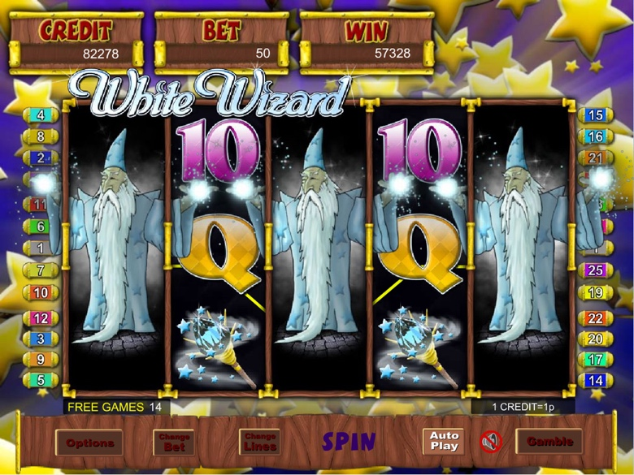

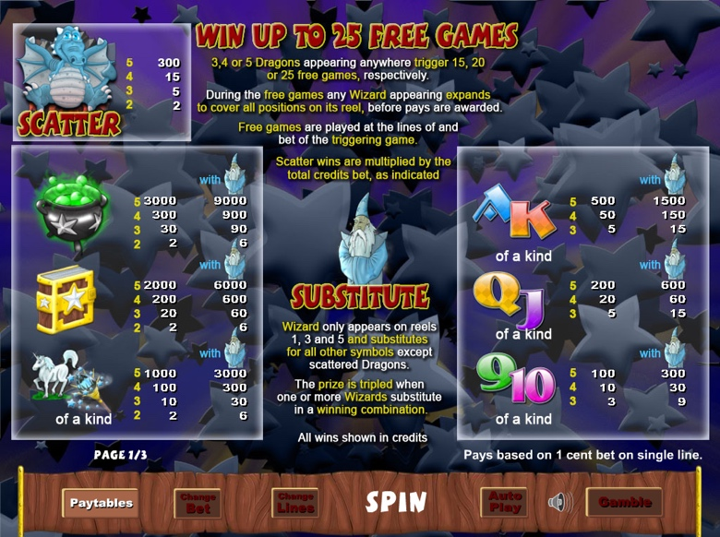

Game Properties & Features

|  |  |
| --- | --- |
| **Properties** | |
| Versions | Standalone, Mini, Mobile |
| RTP (%) | 95 |
| Number of Reels | 5 |
| Number of Lines | 25 |
| Min. Bet | 1 credit |
| Max Bet | 1,250 credits |
| Game Play | Medium |
| Volatility | High |
| Hit Rate playing 1 line | 1 in 8 |
| Combined Feature Hit Rate | 1 in 100 |
| Default Bet | 1 credit per line |
| Supports Free Spins | Yes |
| Recommended Categories | * Fantasy * Big Wins/Volatile * Mystical/Magical |
| **Features** | |
| Free Spins | Up to 25 |
| Substitute | Prizes are tripled |