Game Information for Native Casino App

Introduction
This document aims to capture game information and images for the Native Casino app. Please fill out all the yellow boxes.
This document is required for each game.

General information

Game name
What is the name of your game and the translation to Simplified Chinese? Include a trade mark if applicable.
English | Wild Koi
Simplified Chinese | 野生锦鲤
Traditional Chinese | 百搭錦鯉
Japanese | ワイルド鯉
Korean | 와일드 잉어
Malay | Koi Liar
Spanish | Carpa Comodín

Game code
What is the game code?
pop_788f158e_eye

Winning lines or ways (slot games only)
How many winning lines or ways does your game have?
25 lines

Jackpot
Are jackpots supported in your game? If so, state the jackpot identifier.
Via another game code yes – but this game code is for the non jackpot version

Bet per lines
What is the default bet per line ranges? Please provide in different currencies if such information is available
GBP|EUR|USD [1, 2, 3, 4, 5, 6, 8, 10, 15, 20, 25, 30, 40, 50, 60, 80, 100, 200 ]

Game descriptions
Provide a description of your game in a few sentences for all the lobby languages:
Languages | Description
English (International) | Peace, calm and perhaps even prosperity await you beside the tranquil waters of the koi pond.  As you unwind watching the many colours swim by, keep an eye out for the Red Koi as they will grant you up to 25 free games.  If you're lucky the graceful Gold Koi will appear and swim along the reels. Their presence will triple your wins when they substitute in a winning combination.
Chinese Simplified | 在锦鲤池的宁静水域旁，等待您的是和平、平静，甚至是成功。  当您看着五颜六色的锦鲤游过，放松身心时，请留意红色锦鲤，它们将为您带来多达25次免费游戏。  如果幸运的话，优雅的黄金锦鲤会出现并沿着转轴游动。当它们在赢奖组合中代替时，您将获得三倍的奖金。
Chinese Traditional | 在清澈的錦鯉池邊，平靜、安靜和繁榮在等待著您。  觀看各種顏色的錦鯉在水中游動，放鬆身心。留意紅色錦鯉，它們可能送給您最多25局免費遊戲。  如果您的運氣足夠好，那麼優雅的黃金錦鯉會出現並在捲軸上游動。它們出現時，如果替代其他符號構成獎金組合就會使該獎金翻三倍。
Japanese | 平和、静けさ、そしておそらく繁栄が、錦鯉の池の静かな水辺であなたを待っています。  多彩な色が泳ぐのを見つめくつろぐ中、最大25回のフリーゲームを提供してくれる赤い鯉に注目してください。  もし運が良ければ、優雅な金の鯉が現れ、リールを泳ぎます。彼らの存在は、勝利の組み合わせで代わりに使われた場合、あなたの勝利を3倍にします。
Korean | 잉어 연못의 고요한 물가에서 평화와 고요함, 그리고 번영이 여러분을 기다립니다.  다양한 색상의 물고기가 헤엄치는 모습을 보면서 긴장을 풀다 보면 최대 25회의 무료 게임을 얻을 수 있는 붉은 잉어를 발견할 수 있습니다.  운이 좋으면 우아한 황금 잉어가 나타나 릴을 따라 헤엄쳐 다닐 것입니다. 황금 잉어가 등장하면 승리 조합에 대체되어 승리가 세 배가 됩니다.
Malay | Kedamaian, ketenangan dan mungkin juga kemakmuran menanti anda di sebelah perairan kolam koi yang tenang.  Sambil anda berehat melihat pelbagai warna koi berenang, nantikan Koi Merah kerana ia akan memberikan anda sehingga 25 permainan percuma.  Jika anda bernasib baik, Koi Emas yang anggun akan muncul dan berenang di sepanjang kekili. Kehadirannya akan menggandakan kemenangan anda apabila ia menggantikan dalam kombinasi menang.
Spanish | Paz, calma y quizá incluso prosperidad le esperan en las tranquilas aguas del estanque de las carpas.  A medida que ve todos los colores nadando a su alrededor, no pierda de vista la Carpa Roja, ya que le dará hasta 25 partidas gratis.  Si tiene suerte, aparecerá la grácil Carpa Dorada y nadará por los carretes. Su presencia triplicará sus ganancias cuando sustituyan a otros símbolos en una combinación ganadora.

Images
Note: the assets should be placed in the folders which have the following structure:
- icons with game names should be placed here: games\<game_code>\icons\icons_with_game_names\

Screenshots
The following screenshots are required on mobile in landscape. In case game is available in Portrait only, then screenshots in Portrait (461 x 819) should be provided.
Image type | Screenshot name | Dimensions | Format
Main game in English | screen_<game_code>_main | 819 x 461 | PNG
Significant win in English | screen_<game_code>_big_win | 819 x 461 | PNG
Bonus scene in English | screen_<game_code>_bonus | 819 x 461 | PNG

Game icons
The following game icons are required:
Image Name | Dimensions | Format | Where used in app | Screenshot
<game_code>_icon_5x5 | 240 x 240 | PNG | Quick Switch between games feature | 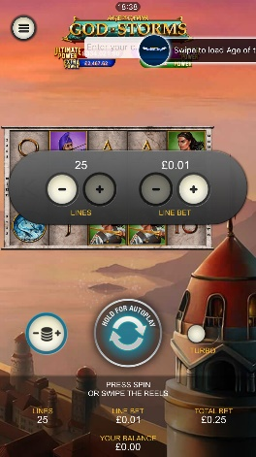
<game_code>_icon_10x10 | 540 x 540 | PNG | Main WL layout: game tiles icons in Lobby, on Game Advisor, Broken games etc. | 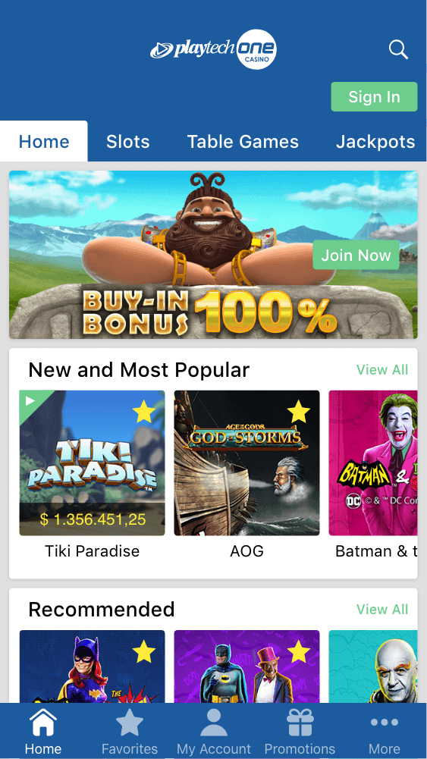  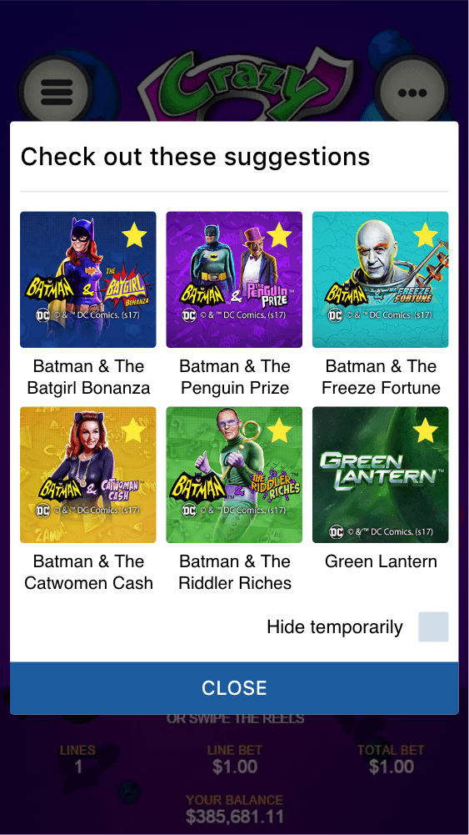
<game_code>_icon_30x5 | 1104 x 336 | PNG | Game Info screen header for tablets | 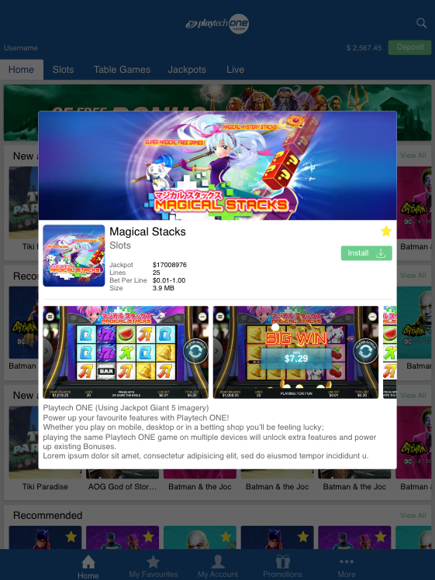
<game_code>_icon_30x10 | 1788 x 540 | PNG | My Favourites screen | 