Xingyun Baozhu

Short Description

Xingyun Baozhu Slots is a vibrant online slot game with a fun and rewarding Chinese theme. Xingyun Baozhu translates to Lucky Firecracker, and lucky you’ll be every time you spin! First of all, you’ll enjoy colourful Chinese lanterns, traditional money envelopes and firecrackers across the reels, and, you can win FREE games. But that’s not all… In addition, Xingyun Baozhu Slots has a 94.9% RTP, which is most noteworthy. Take a trip to China from the comfort of your home today and every day that you play and win big!

**Formats**

* Stand Alone
* Embedded
* Mobile

**Recommended categories**

* Chinese New Year
* Huge Wins

Marketing Materials

The materials can be downloaded from [here](https://files.eyecon.com/index.php/s/XLUSvdy2fasAJWq)

Screenshot

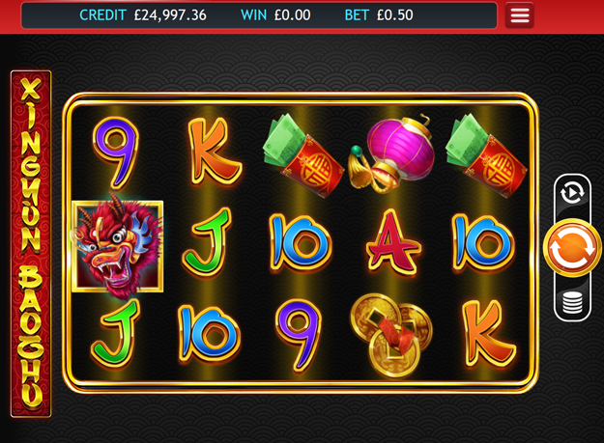

Game Properties & Features

|  |  |
| --- | --- |
| **Properties** | |
| Versions | Standalone, Mini, Mobile |
| RTP (%) | 95 |
| Number of Reels | 5 |
| Number of Lines | 25 |
| Min. Bet | 1 credit |
| Max Bet | 1,250 credits |
| Game Play | Medium |
| Volatility | High |
| Hit Rate playing 1 line | 1 in 7.8 |
| Combined Feature Hit Rate | 1 in 100 |
| Default Bet | 1 credit per line |
| Supports Free Spins | Yes |
| Recommended Categories | * Big Wins/Volatile * Seasonal/Festive |
| **Features** | |
| Free Spins | Up to 25 |
| Substitute | Firecracker Symbol triples prizes |