XMAS CASH

Short Description
Christmas has come early to reward you with presents packed with prizes! You’ll be laughing all the way through 8 magical Free Games. Unwrap your fortunes in the exciting Prize Pick Feature! It’s a 3-reel, 9-line mini-slot packed with fun and Christmas cheer! Look out for the Bells and Christmas Trees for more Christmas cash today!

Marketing Materials
The materials can be downloaded from here
Screenshots
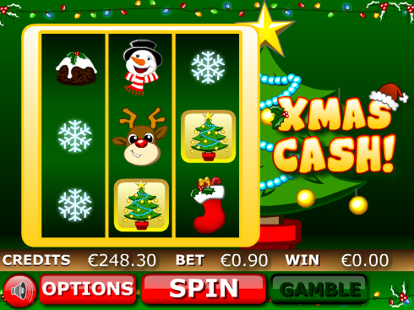

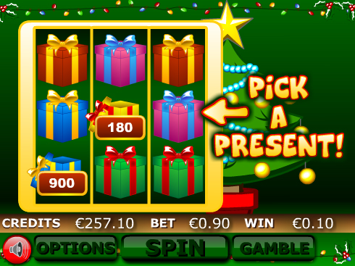
Game Properties & Features

Properties
Versions | Mini, Mobile
RTP (%) | 95
Number of Reels | 3
Number of Lines | 9
Min. Bet | 1 credit
Max Bet | 900 credits
Game Play | Hard
Volatility | High
Hit Rate playing 1 line | 1 in 16
Combined Feature Hit Rate | 1 in 79
Default Bet | 10 credits/line playing 9 lines
Supports Free Spins | Yes
Recommended Categories | - Festive/Seasonal – Christmas!  - Big Wins/Volatile
Features
Free Spins | Up to 8
Substitute | Xmas Cash Logo
Prize Pick Feature | Triggered by 3 Tree Symbols

