Game Information for Native Casino App

Introduction
This document aims to capture game information and images for the Native Casino app. Please fill out all the yellow boxes.
This document is required for each game.

General information

Game name
What is the name of your game and the translation to Simplified Chinese? Include a trade mark if applicable.
English | Xmas Cash
Simplified Chinese | 圣诞现金
Traditional Chinese | 聖誕現金
Japanese | クリスマスキャッシュ
Korean | 크리스마스 캐시
Malay | Tunai Krismas
Spanish | Dinero de Navidad

Game code
What is the game code?
pop_xmascash_eye

Winning lines or ways (slot games only)
How many winning lines or ways does your game have?
9 Line

Jackpot
Are jackpots supported in your game? If so, state the jackpot identifier.
Via another game code yes – but this game code is for the non jackpot version

Bet per lines
What is the default bet per line ranges? Please provide in different currencies if such information is available
GBP|EUR|USD [ 1, 2, 5, 8, 10, 15, 20, 30, 50, 75, 100, 125, 150, 200, 250, 300, 500, 1000 ]

Game descriptions
Provide a description of your game in a few sentences for all the lobby languages:
Languages | Description
English (International) | Christmas is in the air, and Santa’s feeling extra generous! Ho Ho Ho! Xmas Cash Slots is filled with sparkling Christmas trees, festive bells, Santa himself, reindeer, Christmas treats and more! It’s sure to get you in the holiday spirit in no time. So, put on your favourite Christmas movie, pour yourself a glass of eggnog, and start spinning away in Xmas Cash Slots!
Chinese Simplified | 圣诞节即将来临，圣诞老人显得格外慷慨！嗬嗬嗬！圣诞现金老虎机裡装满了闪闪发光的圣诞树、节日铃铛、圣诞老人本人、驯鹿、圣诞礼物等等！它一定会让你立刻感受到节日的气氛。那么，放上你最喜欢的圣诞电影，给自己倒一杯蛋酒，然后开始旋转圣诞现金老虎机吧！
Chinese Traditional | 聖誕節即將來臨，聖誕老人顯得格外慷慨！嗬嗬嗬！聖誕現金老虎機裡裝滿了閃閃發光的聖誕樹、節日鈴鐺、聖誕老人本人、馴鹿、聖誕禮物等等！它一定會讓你立刻感受到節日的氣氛。那麼，放上你最喜歡的聖誕電影，給自己倒一杯蛋酒，然後開始旋轉聖誕現金老虎機吧！
Japanese | クリスマスの雰囲気が高まり、サンタクロースはすごく気前が良くなっています！ハイ、ハイ、ハイ！クリスマスキャッシュスロットには輝くクリスマスツリー、祝祭のベル、サンタ自身、トナカイ、クリスマスのスイーツなどが溢れています！あっという間にホリデーの気持ちに切り替わりること間違いなし。そこで、大好きなクリスマスの映画をセットし、エッグノッグを一杯頂きながら、クリスマスキャッシュスロットを回しましょう！
Korean | 크리스마스 다가오고 있습니다. 산타가 후한 선물을 준비했다고 하네요! 호 호 호! 크리스마스 캐시 슬롯에는 반짝이는 크리스마스트리, 크리스마스 종, 산타, 순록, 크리스마스 간식 등이 가득 들어있습니다! 당장이라도 크리스마스 분위기에 흠뻑 빠질 거예요! 가장 좋아하는 크리스마스 영화를 틀고, 에그노그를 한잔 따른 뒤, 크리스마스 캐시 슬롯에서 스핀을 시작해보세요!
Malay | Ia musim Krismas, dan Santa rasa amat murah hati! Ho Ho Ho! Slot Tunai Krismas dipenuhi pokok Krismas, loceng bermusim, Santa sendiri, rusa, sajian Krismas dan banyak lagi! Anda pasti merasai semangat bercuti dengan segera. Jadi, pasang filem Krismas kegemaran anda, tuang secawan eggnog, dan mula putarkan Slot Tunai Krismas!
Spanish | ¡La Navidad está en el ambiente y Santa se siente especialmente generoso! ¡Jo, jo, jo! La tragaperras de Dinero de Navidad está llena de árboles de Navidad relucientes, campanillas festivas, el propio Santa, renos, dulces de Navidad y mucho más! Sin duda te meterá de lleno en el espíritu navideño. ¡Así que ponte tu película navideña favorita, sírvete un ponche de huevo y empieza a tirar en la tragaperras de Dinero de Navidad!

Images
Note: the assets should be placed in the folders which have the following structure:
- icons with game names should be placed here: games\<game_code>\icons\icons_with_game_names\

Screenshots
The following screenshots are required on mobile in landscape. In case game is available in Portrait only, then screenshots in Portrait (461 x 819) should be provided.
Image type | Screenshot name | Dimensions | Format
Main game in English | screen_<game_code>_main | 819 x 461 | PNG
Significant win in English | screen_<game_code>_big_win | 819 x 461 | PNG
Bonus scene in English | screen_<game_code>_bonus | 819 x 461 | PNG

Game icons
The following game icons are required:
Image Name | Dimensions | Format | Where used in app | Screenshot
<game_code>_icon_5x5 | 240 x 240 | PNG | Quick Switch between games feature | 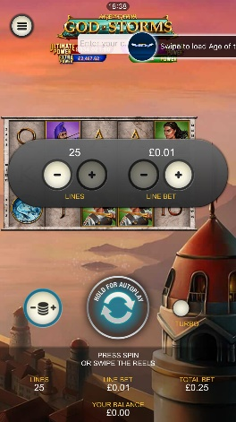
<game_code>_icon_10x10 | 540 x 540 | PNG | Main WL layout: game tiles icons in Lobby, on Game Advisor, Broken games etc. | 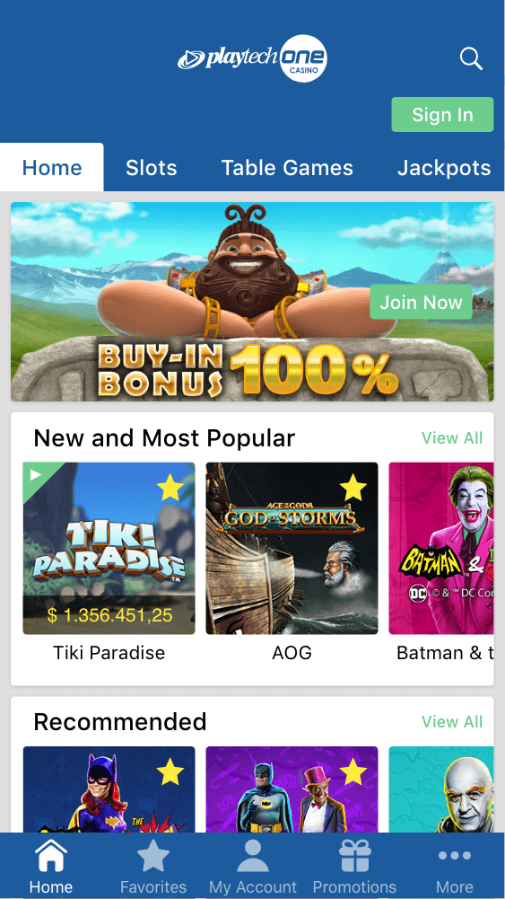  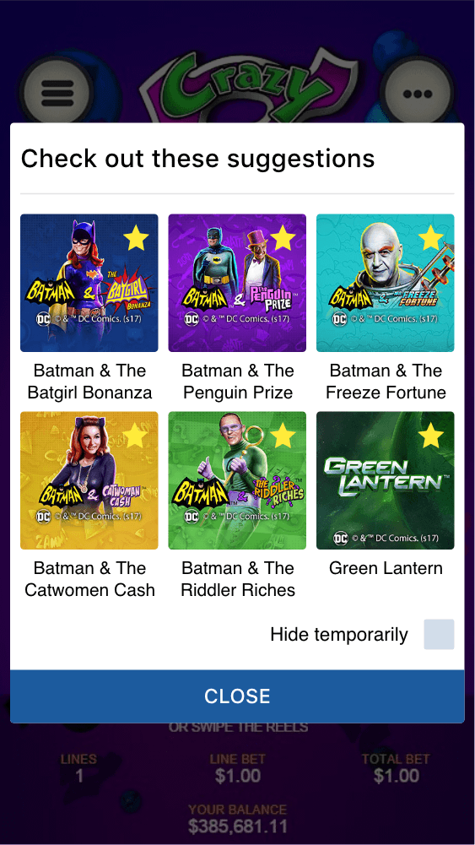
<game_code>_icon_30x5 | 1104 x 336 | PNG | Game Info screen header for tablets | 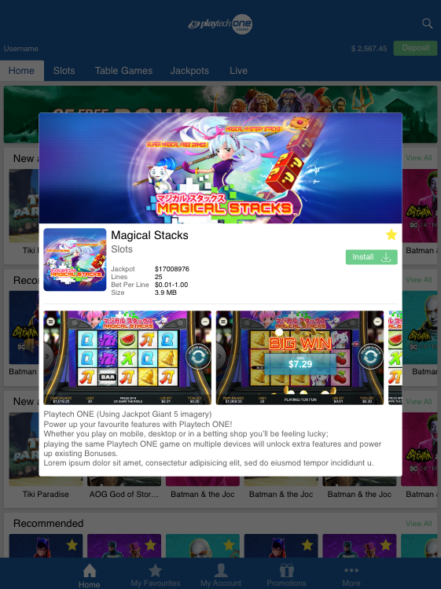
<game_code>_icon_30x10 | 1788 x 540 | PNG | My Favourites screen | 