XMAS CASH

Short Description

Christmas has come early to reward you with presents packed with prizes! You’ll be laughing all the way through 8 magical Free Games. Unwrap your fortunes in the exciting Prize Pick Feature! It’s a 3-reel, 9-line mini-slot packed with fun and Christmas cheer! Look out for the Bells and Christmas Trees for more Christmas cash today!

Marketing Materials

The materials can be downloaded from [here](https://files.eyecon.com/index.php/s/MD7fSl7ul19sHqy)

Screenshots

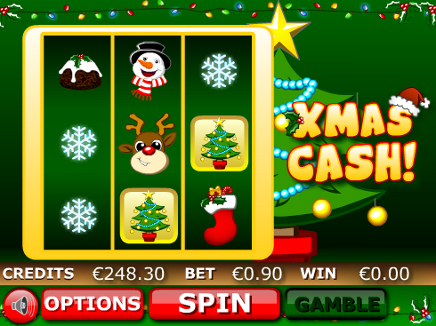

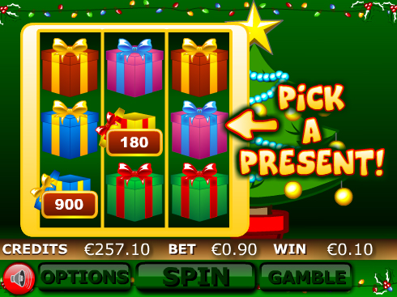

Game Properties & Features

|  |  |
| --- | --- |
| **Properties** | |
| Versions | Mini, Mobile |
| RTP (%) | 95 |
| Number of Reels | 3 |
| Number of Lines | 9 |
| Min. Bet | 1 credit |
| Max Bet | 900 credits |
| Game Play | Hard |
| Volatility | High |
| Hit Rate playing 1 line | 1 in 16 |
| Combined Feature Hit Rate | 1 in 79 |
| Default Bet | 10 credits/line playing 9 lines |
| Supports Free Spins | Yes |
| Recommended Categories | * Festive/Seasonal – Christmas! * Big Wins/Volatile |
| **Features** | |
| Free Spins | Up to 8 |
| Substitute | Xmas Cash Logo |
| Prize Pick Feature | Triggered by 3 Tree Symbols |