Game Information for Native Casino App

Introduction
This document aims to capture game information and images for the Native Casino app. Please fill out all the yellow boxes.
This document is required for each game.

General information

Game name
What is the name of your game and the translation to Simplified Chinese? Include a trade mark if applicable.
English | Yoyo’s Wild
Simplified Chinese | 疯狂悠悠球
Traditional Chinese | 瘋狂悠悠球
Japanese | Yoyoの野生
Korean | 요요스 와일드
Malay | Liar bersama YoYo
Spanish | Yoyó salvaje

Game code
What is the game code?
pop_yoyoswild_eye

Winning lines or ways (slot games only)
How many winning lines or ways does your game have?
25 Line

Jackpot
Are jackpots supported in your game? If so, state the jackpot identifier.
Via another game code yes – but this game code is for the non jackpot version

Bet per lines
What is the default bet per line ranges? Please provide in different currencies if such information is available
GBP|EUR|USD [ 1, 2, 3, 4, 5, 6, 8, 10, 15, 20, 25, 30, 40, 50, 100, 200 ]

Game descriptions
Provide a description of your game in a few sentences for all the lobby languages:
Languages | Description
English (International) | “Walk the Dog” or go “Two-Handed” with the world’s first YoYo-themed Slot Game. The innovative trick feature creates a pattern of substitute symbols based on four classic YoYo tricks which then creates additional pay lines. All you need to trigger the trick-selector is spin 3 scatters on the reels and the feature will present you with between 2-3 tricks.There is nothing quite like this game, so take a nostalgic trip down memory lane and play to see what all the excitement is about!
Chinese Simplified | 用世界上第一款悠悠球主题的老虎机游戏挑战“遛狗”或者“双手式”吧。。创造性的招式功能打造了替代符号模式，这种模式是基于四种经典的悠悠球招式，同时创造了额外的支付线。您只需要在卷轴上旋转出3个分散符号就可以触发招式选择器，这个功能会为您呈现2-3个招式。没有什么比这更棒的游戏了，追忆往事，来一次怀旧之旅，尽情地玩耍，看看会遇到什么激动人心的惊喜吧！
Chinese Traditional | 用世界上第一款悠悠球主題的老虎機遊戲挑戰“遛狗”或者“雙手式”吧。。創造性的招式功能打造了替代符號模式，這種模式是基於四種經典的悠悠球招式，同時創造了額外的支付線。您只需要在卷軸上旋轉出3個分散符號就可以觸發招式選擇器，這個功能會為您呈現2-3個招式。沒有什麽比這更棒的遊戲了，追憶往事，來一次懷舊之旅，盡情地玩耍，看看會遇到什麽激動人心的驚喜吧！
Japanese | 世界初のYoYoをテーマにしたスロットゲームで、 「犬散歩」 または 「両手」 をやります。革新的なトリック機能は、四つの古典的なYoYoトリックに基づいて代替シンボルのパターンを作成し、追加の支払い明細を作成します。トリックセレクタをトリガする必要があるのは、リール上のスピン3スキャッタだけで、この機能は2～3つのトリックを提示します。このゲームのようなものはありませんので、思い出のレーンをノスタルジックな旅をして、すべての興奮が何であるかを見るために遊んでください！
Korean | 세계 최초의 요요 테마 슬롯 게임에서 요요를 이용한 '강아지 산책'이나 '두 손' 트릭에 도전해보세요. 혁신적인 트릭 기능이 네 가지 클래식한 요요 트릭을 바탕으로 대체 심볼 패턴을 만들어 추가 페이 라인을 형성합니다. 트릭을 선택하려면 릴의 스캐터 3개를 돌리면 됩니다. 기능이 발동되며 2~3개의 트릭이 등장합니다. 이것만 한 게임은 없어요. 향수를 일으키는 추억 여행을 떠나 신나게 플레이해보세요!
Malay | "Jalan Bersama Anjing" atau pilih "Dua Tangan" dengan Permainan Slot bertemakan YoYo pertama di dunia. Ciri helah inovatif mencipta corak simbol pengganti berdasarkan empat helah YoYo klasik yang kemudiannya mencipta garisan gaji tambahan. Apa yang anda perlukan untuk mencetuskan pemilih helah adalah putaran 3 hamburan pada kekili dan ciri ini akan memberikan anda antara 2-3 helah. Tiada yang serupa dengan permainan ini, jadi ikuti perjalanan nostalgia ke dalam ingatan dan bermain untuk melihat semua keseronokan!
Spanish | "Pasea al perro" o ve "A dos manos" con la primera tragaperras con el tema del yoyó. La innovadora función de truco crea un patrón de símbolos sustitutos basados en cuatro trucos de yoyó básicos que crea líneas de pago adicionales. Lo único que tienes que hacer para activar el selector de trucos es sacar 3 scatters en los rodillos y la función te ofrecerá 2-3 trucos. No hay nada parecido a este juego, ¡así que haz un viaje a la nostalgia por la calle de los recuerdos y juega para ver a qué viene toda esta emoción!

Images
Note: the assets should be placed in the folders which have the following structure:
- icons with game names should be placed here: games\<game_code>\icons\icons_with_game_names\

Screenshots
The following screenshots are required on mobile in landscape. In case game is available in Portrait only, then screenshots in Portrait (461 x 819) should be provided.
Image type | Screenshot name | Dimensions | Format
Main game in English | screen_<game_code>_main | 819 x 461 | PNG
Significant win in English | screen_<game_code>_big_win | 819 x 461 | PNG
Bonus scene in English | screen_<game_code>_bonus | 819 x 461 | PNG

Game icons
The following game icons are required:
Image Name | Dimensions | Format | Where used in app | Screenshot
<game_code>_icon_5x5 | 240 x 240 | PNG | Quick Switch between games feature | 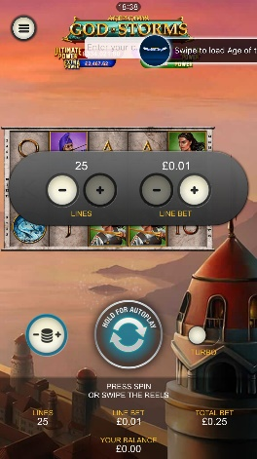
<game_code>_icon_10x10 | 540 x 540 | PNG | Main WL layout: game tiles icons in Lobby, on Game Advisor, Broken games etc. | 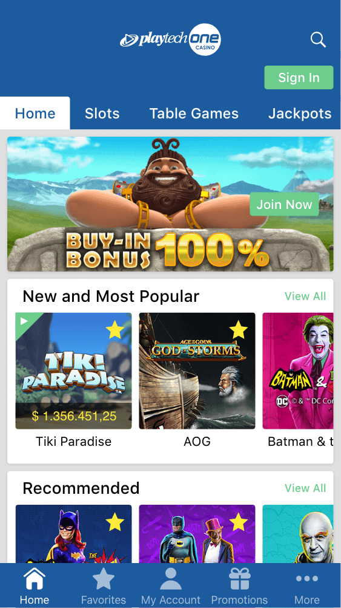  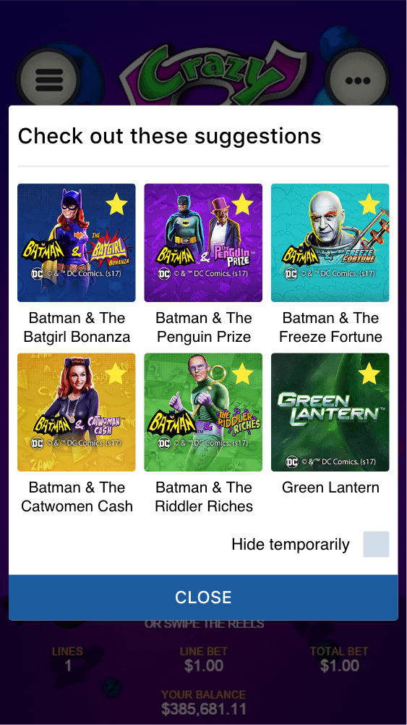
<game_code>_icon_30x5 | 1104 x 336 | PNG | Game Info screen header for tablets | 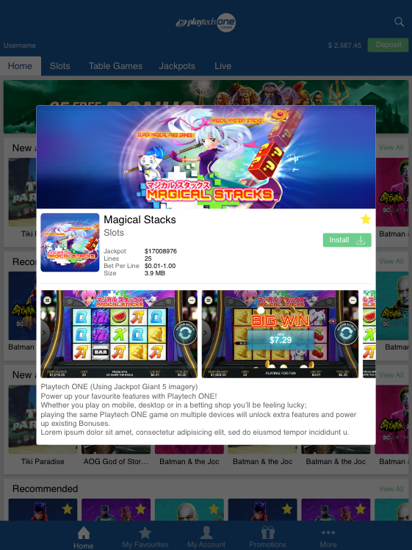
<game_code>_icon_30x10 | 1788 x 540 | PNG | My Favourites screen | 