Game Information for Native Casino App

Introduction
This document aims to capture game information and images for the Native Casino app. Please fill out all the yellow boxes.
This document is required for each game.

General information

Game name
What is the name of your game and the translation to Simplified Chinese? Include a trade mark if applicable.
English | Tikki Beats
Simplified Chinese | 提基节拍
Traditional Chinese | 提基節拍
Japanese | ティッキー・ビーツ
Korean | 티키 비트
Malay | Rentak Tikki
Spanish | Tikki Beats

Game code
What is the game code?
pop_4e51532f_eye

Winning lines or ways (slot games only)
How many winning lines or ways does your game have?
25 lines

Jackpot
Are jackpots supported in your game? If so, state the jackpot identifier.
Via another game code yes – but this game code is for the non jackpot version

Bet per lines
What is the default bet per line ranges? Please provide in different currencies if such information is available
GBP|EUR|USD [1, 2, 3, 4, 5, 6, 8, 10 15, 20, 25, 30, 40, 50, 60, 80, 100, 200]

Game descriptions
Provide a description of your game in a few sentences for all the lobby languages:
Languages | Description
English (International) | Aloha, it’s time to embark on an adventure deep into the Jungle in Brand New Tiki Beats. The drums are calling you to big wins with a chance to win Free Spins, the Toucan Bonus Feature and the Super Gold Tiki Bonus Feature. Start your adventure and discover the Tiki Idols now!
Chinese Simplified | 嘿，是时候跟随全新的《提基节拍》开启一场丛林大冒险啦！隆隆鼓声正在召唤你前来赢取大奖。同时，你还有机会获得免费旋转、犀鸟红利游戏玩法和超级黄金提基红利游戏玩法。立即开启冒险之旅，探秘提基神像！
Chinese Traditional | 阿羅哈，跟隨耳目一新的《提基節拍》，深入叢林開啟一場冒險之旅。激蕩的鼓聲正在召喚你前來贏取大獎，更有機會喜獲免費旋轉、犀鳥紅利遊戲玩法和超級黃金提基紅利遊戲玩法。即可開啟冒險旅程，探索提基神像！
Japanese | アロハ、真新しいティッキー・ビーツでジャングルへのアドベンチャーへ出かけましょう。ドラムは、フリースピン、大嘴鳥ボーナス機能、スーパーゴールドティッキーボーナス機能を獲得するチャンスで大勝利を呼び込んでいます。アドベンチャーを始めて、ティッキーアイドルを今すぐ発見しましょう!
Korean | 알로하, 이제 브랜드 뉴 티키 비트 의 정글속 깊이 모험을 떠날 시간입니다. 드럼은 프리 스핀과 투칸 보너스 기능, 슈퍼 골드 티키 보너스 기능을 획득할 수 있는 기회와 함께 큰 승리로 여러분을 부르고 있습니다. 지금 모험을 시작하고 티키 아이돌을 발견하십시오!
Malay | Aloha, sudah tiba masanya untuk memulakan pengembaraan jauh ke dalam Hutan dalam Rentak Tiki Serba Baharu. Gelendong memanggil anda untuk menang besar dengan peluang untuk memenangi Putaran Percuma, Ciri Bonus Toucan dan Ciri Bonus Tiki Super Emas. Mulakan pengembaraan anda dan temui Idol Tiki sekarang!
Spanish | ¡Aloha! Es hora de embarcarse en una aventura en lo profundo de la jungla con el nuevo juego Tiki Beats. Los tambores llaman desde grandes ganancias, con la oportunidad de ganar giros gratis, la bonificación Tucán y la bonificación especial Tiki Súper Oro. ¡Comience su aventura ahora y encuentre los ídolos Tiki!

Images
Note: the assets should be placed in the folders which have the following structure:
- icons with game names should be placed here: games\<game_code>\icons\icons_with_game_names\

Screenshots
The following screenshots are required on mobile in landscape. In case game is available in Portrait only, then screenshots in Portrait (461 x 819) should be provided.
Image type | Screenshot name | Dimensions | Format
Main game in English | screen_<game_code>_main | 819 x 461 | PNG
Significant win in English | screen_<game_code>_big_win | 819 x 461 | PNG
Bonus scene in English | screen_<game_code>_bonus | 819 x 461 | PNG

Game icons
The following game icons are required:
Image Name | Dimensions | Format | Where used in app | Screenshot
<game_code>_icon_5x5 | 240 x 240 | PNG | Quick Switch between games feature | 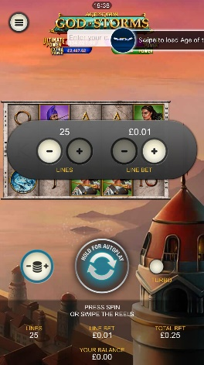
<game_code>_icon_10x10 | 540 x 540 | PNG | Main WL layout: game tiles icons in Lobby, on Game Advisor, Broken games etc. |   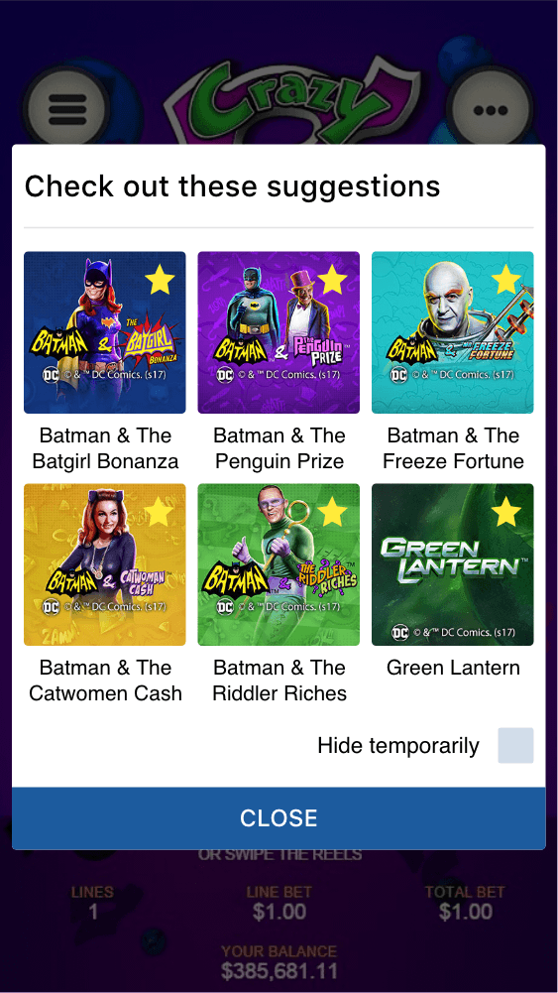
<game_code>_icon_30x5 | 1104 x 336 | PNG | Game Info screen header for tablets | 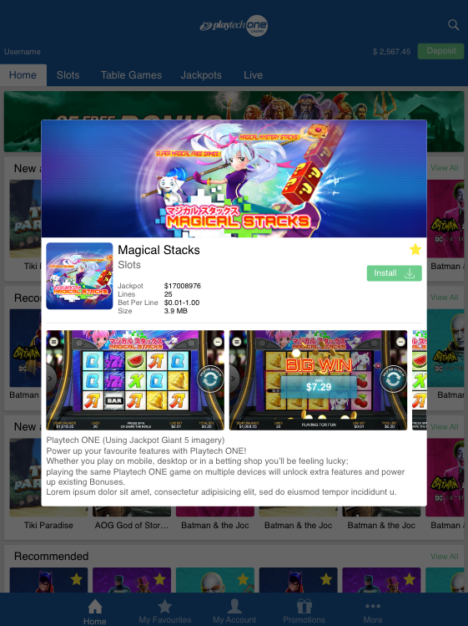
<game_code>_icon_30x10 | 1788 x 540 | PNG | My Favourites screen | 